Created Instances on AWS name as developer-server, Jenkins server and Tomcat server with same key-pair and same security group.

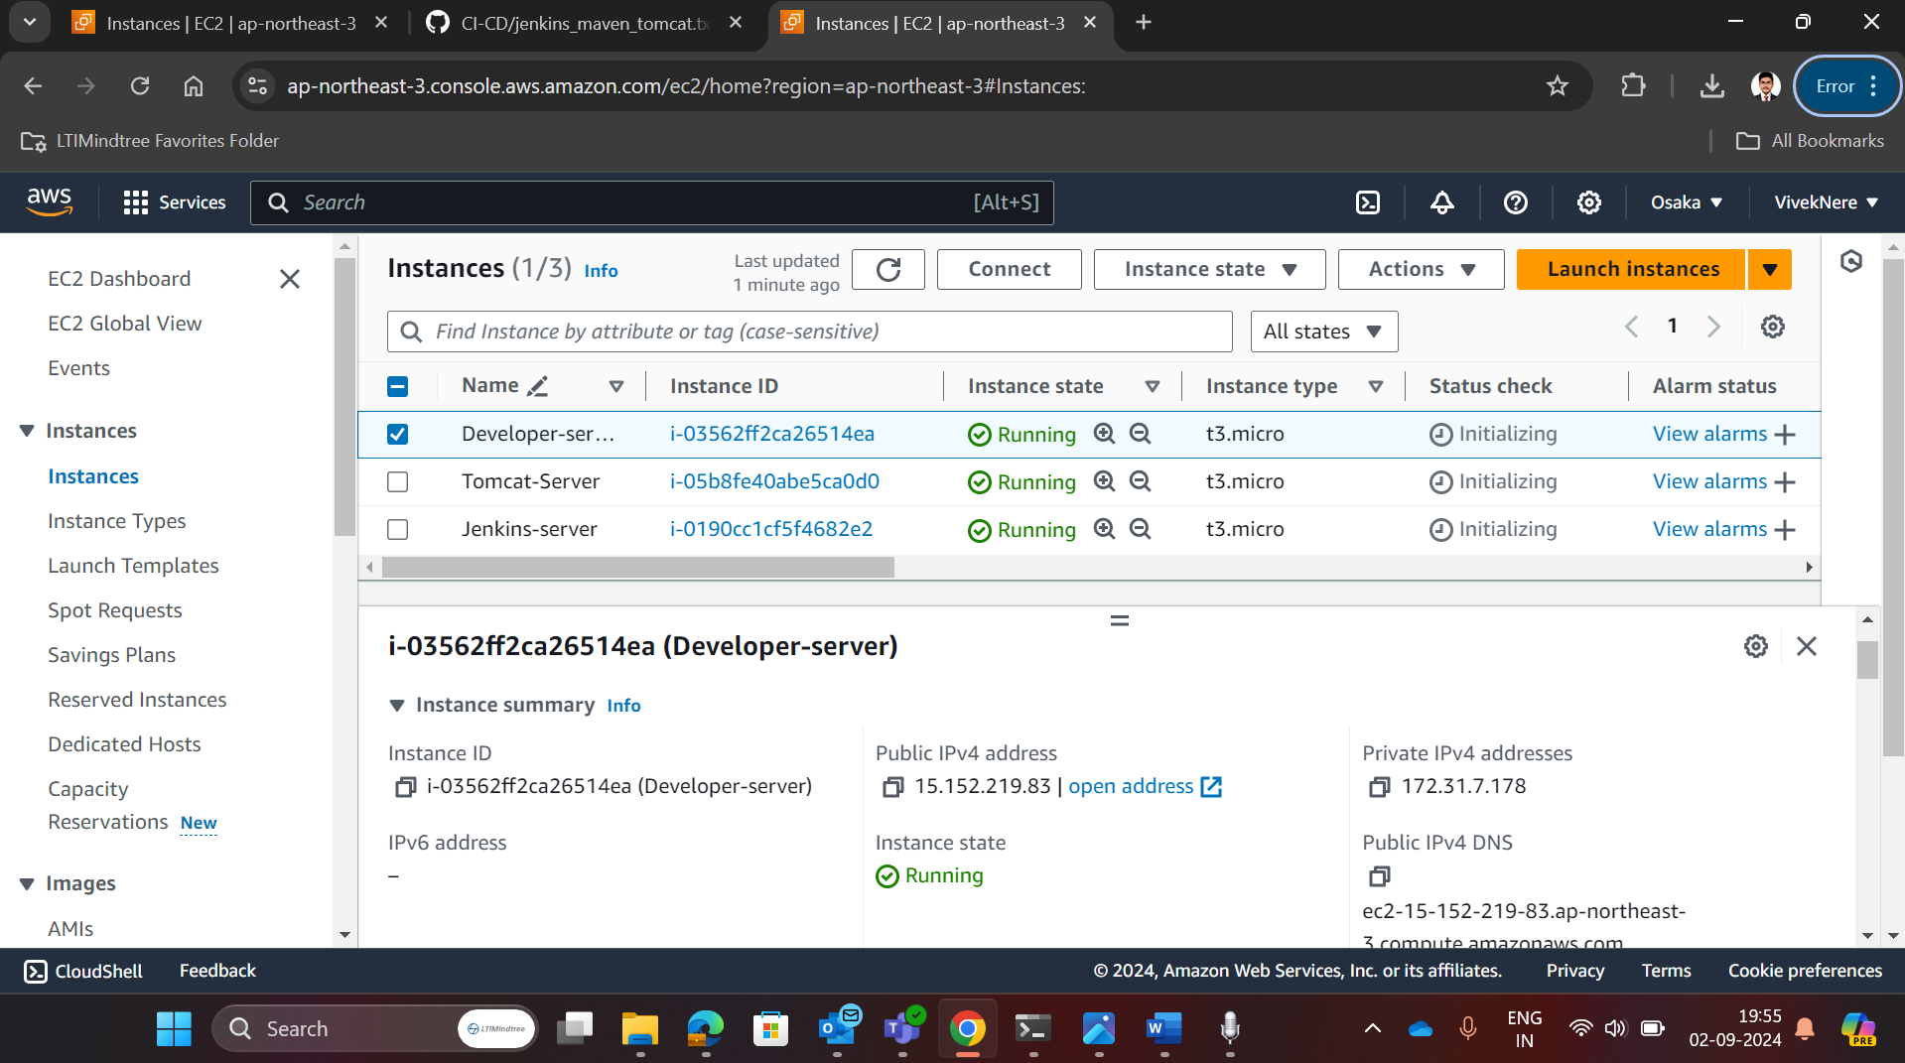

Connected developer server instance with local system through ssh and gave it a localhost name as developer-server

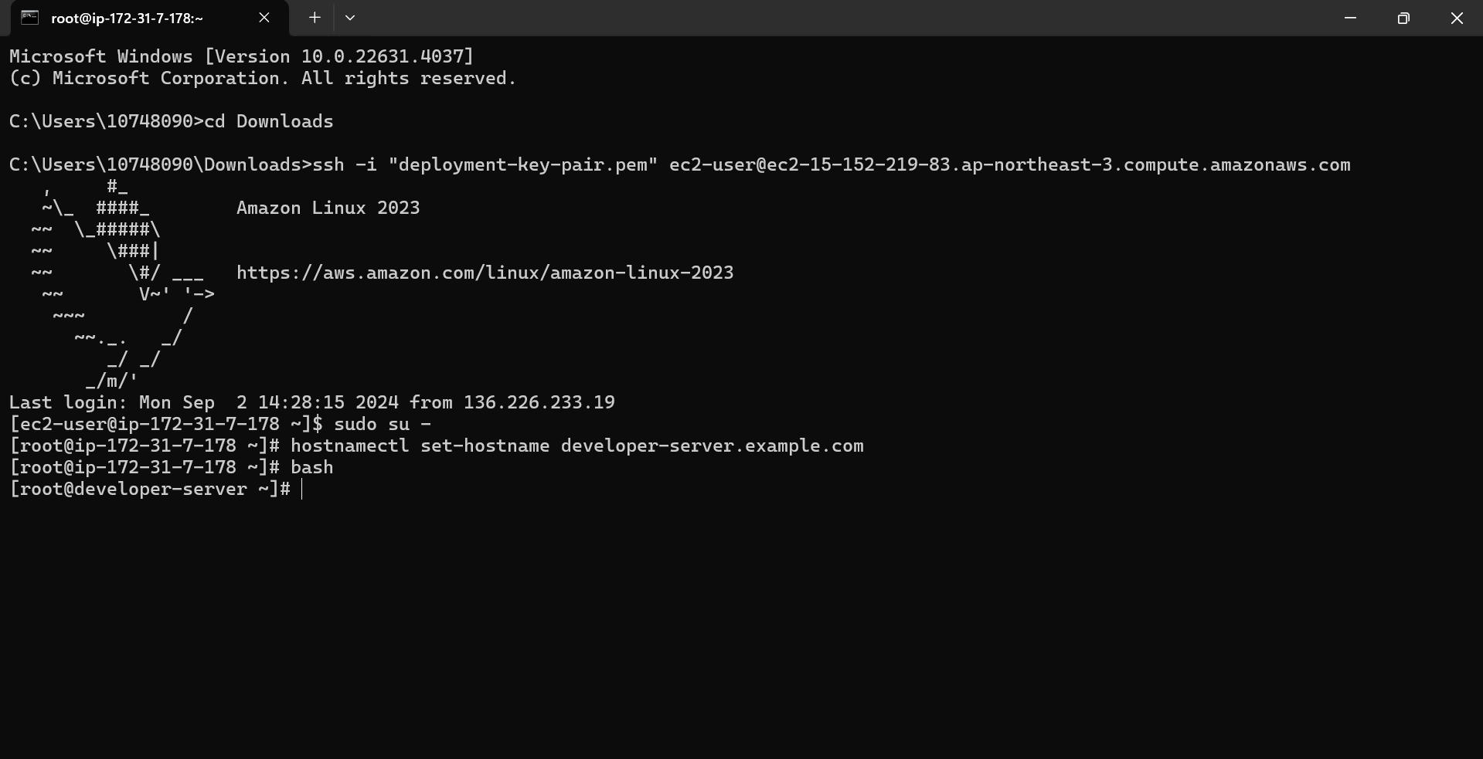

Installed and initialized git in developer-server

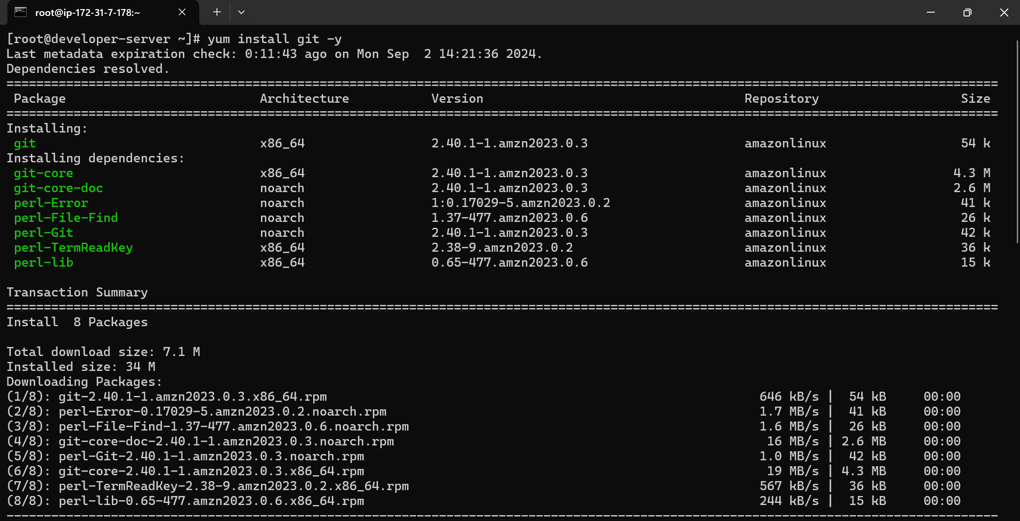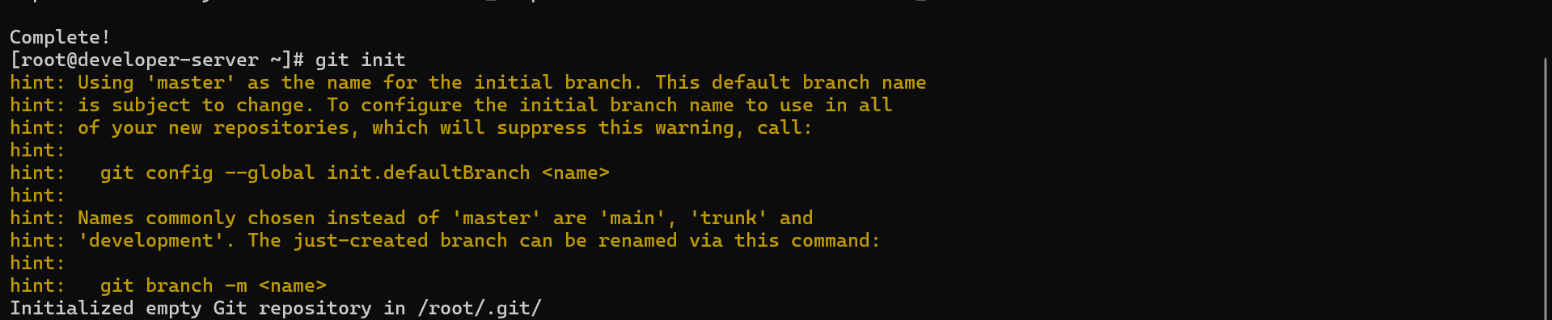

Created and added public ssh-key to github-account for ssh-authentication

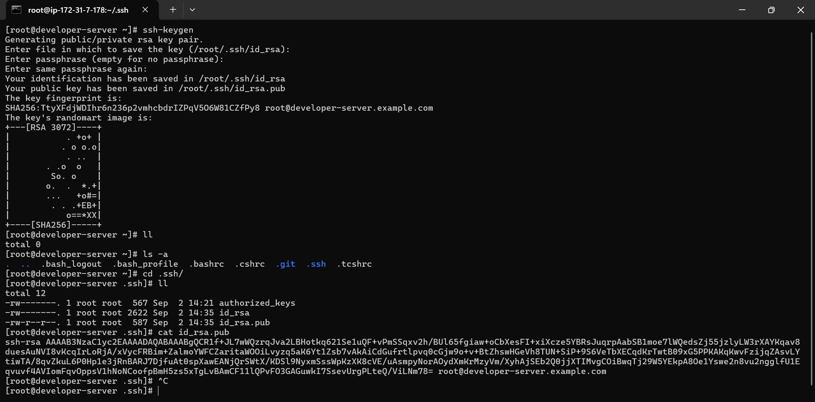

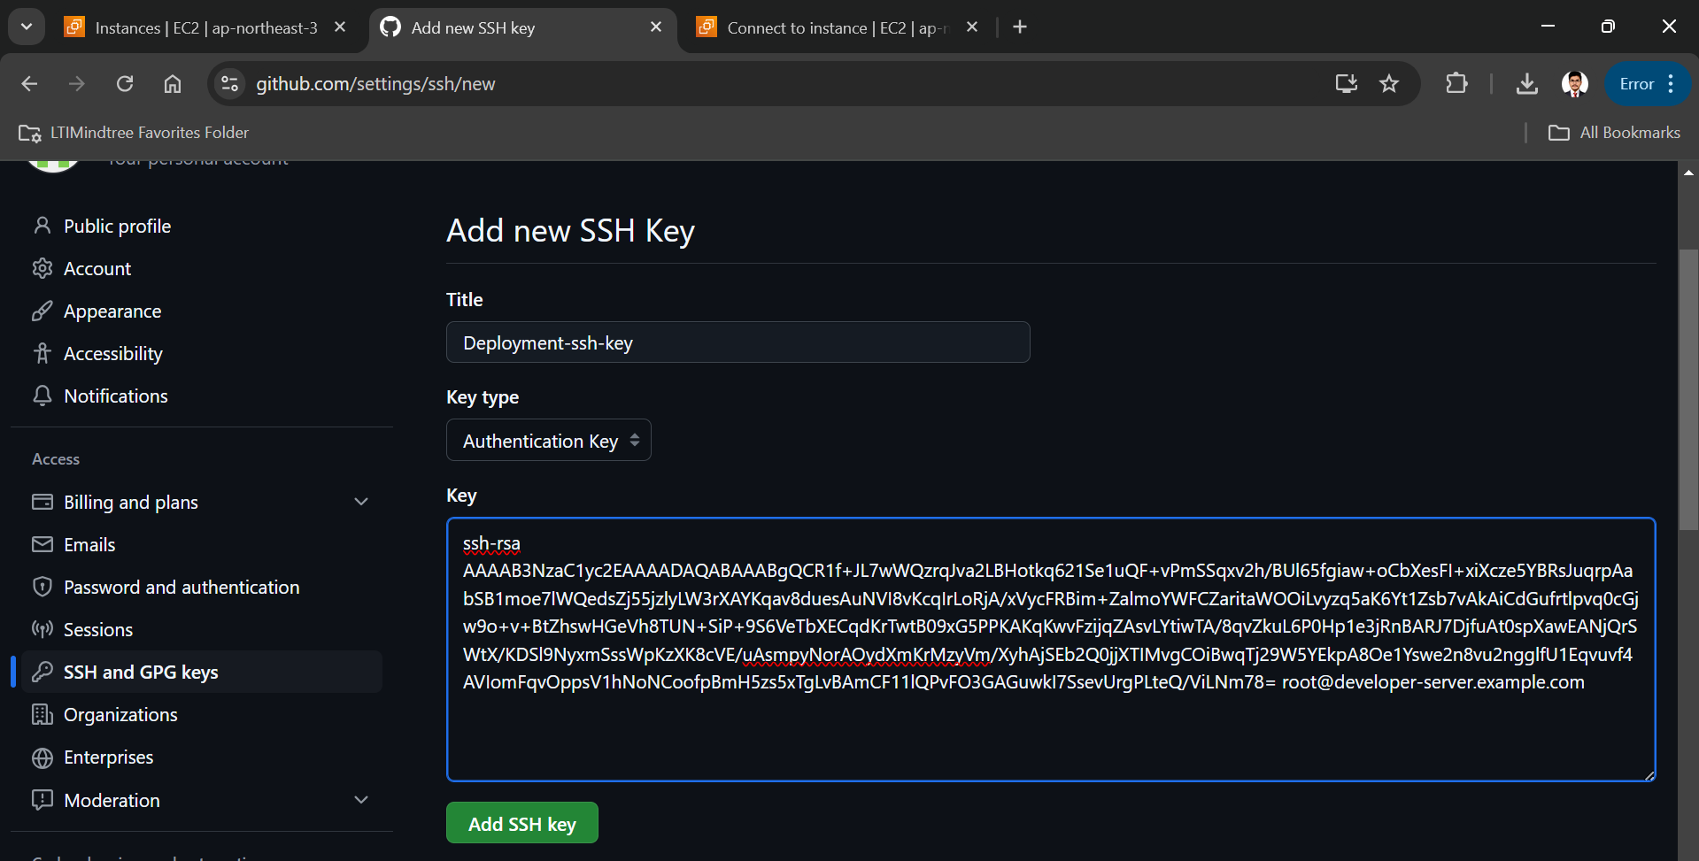

CLONE JAVA PROJECT FROM GIT REPOSITORTY WHERE IT IS PRESENT

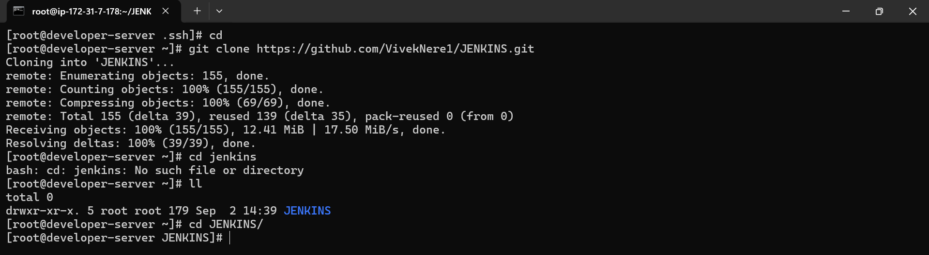

Created deployment name repository in my account to push the code in that repository which we have cloned just now

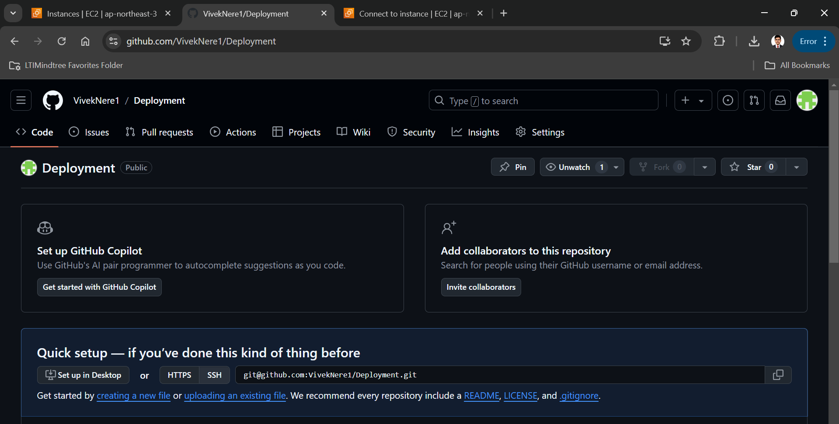

Now we have successfully push the code on my own branch

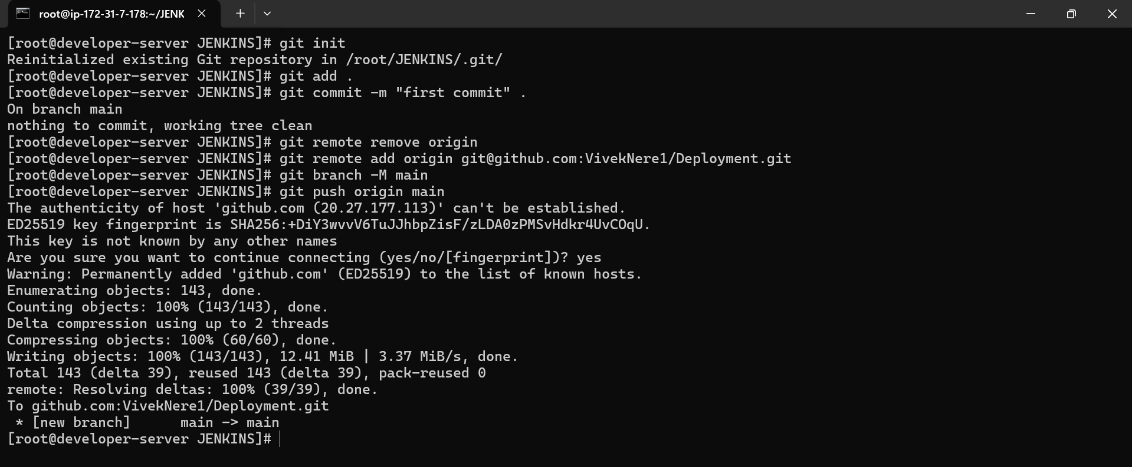

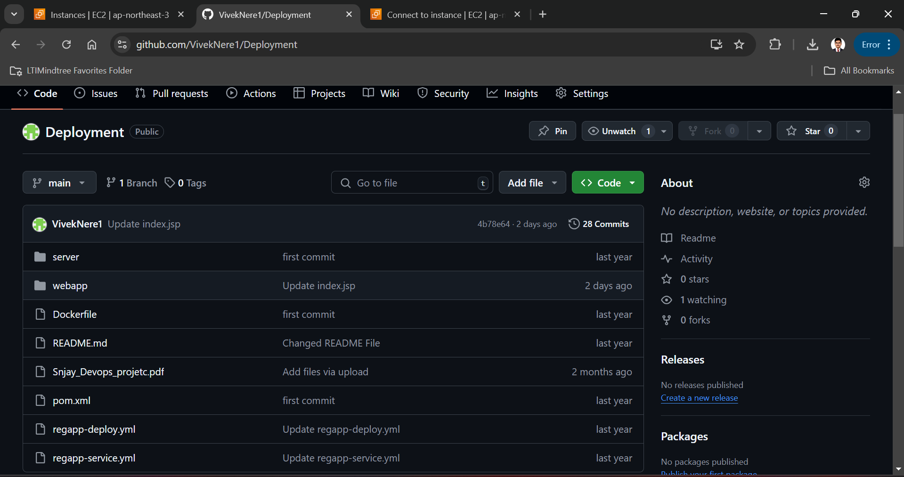

Now we have to open Jenkins-server instance in our machine using ssh and I have gave the hostname as Jenkins-server

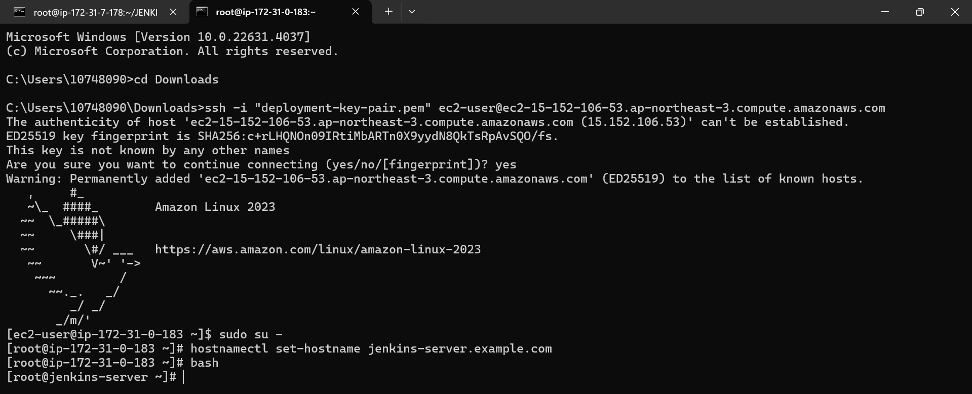

Now we have to add one extra inbound rule in security group for Jenkins server instance with port number 8080

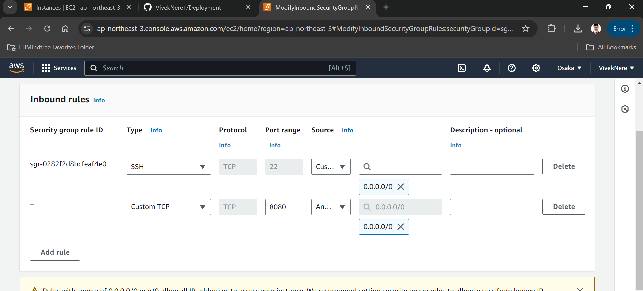

Now we have to install and initialized git in Jenkins-server

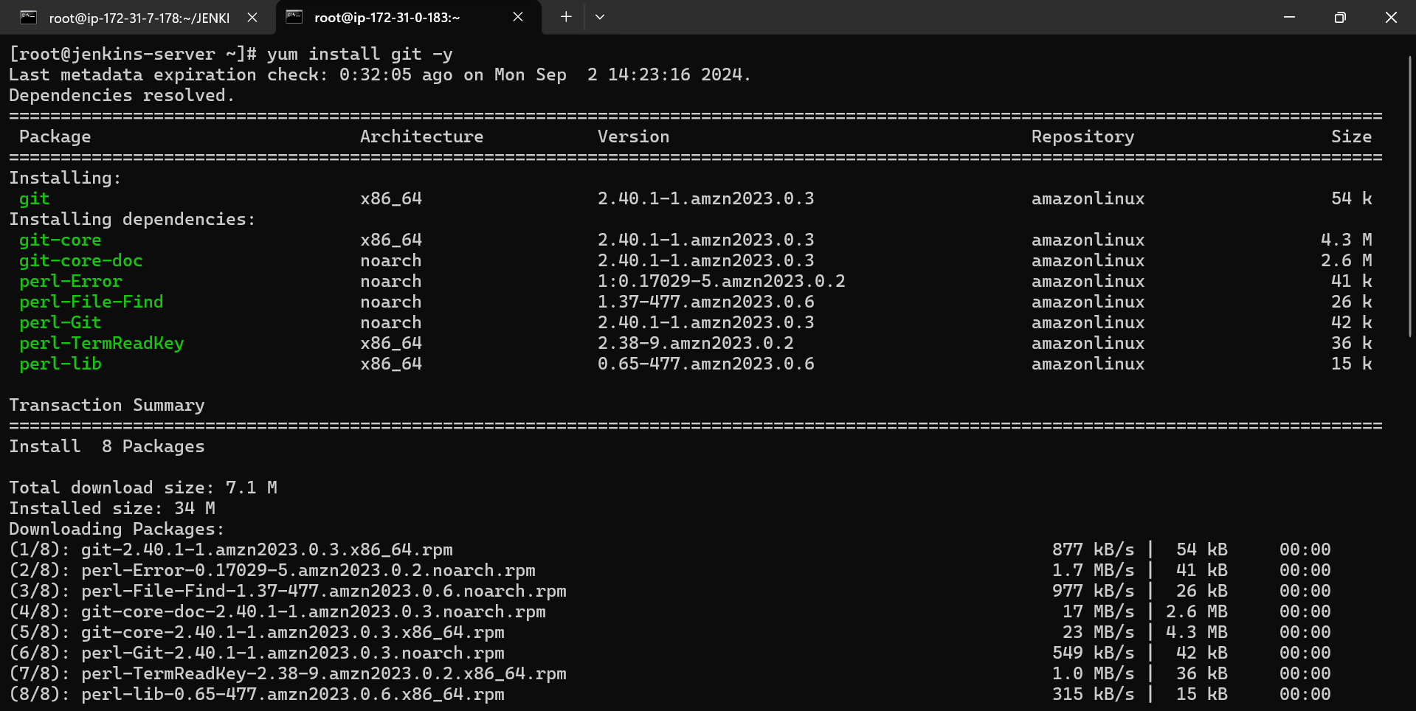

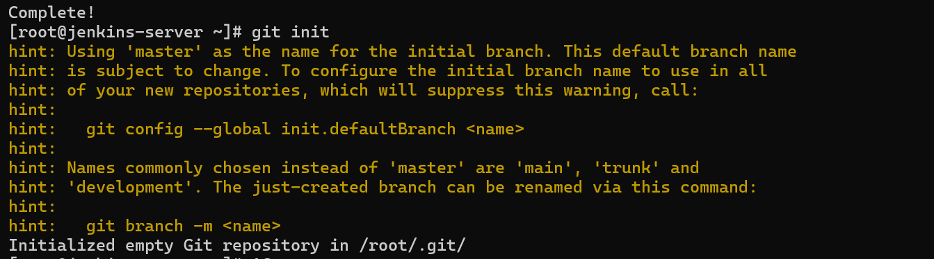

Now we have to install and configure java and Jenkins on Jenkins-server

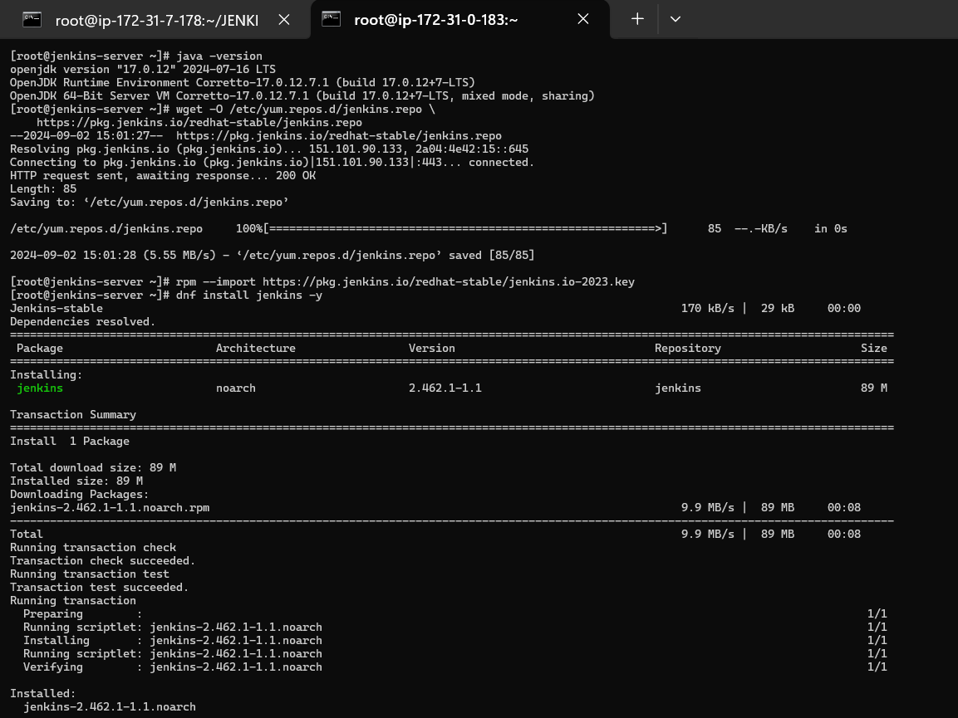

Enable and started Jenkins



Accessed Jenkins dashboard via, Jenkins-server machine’s public ip address and 8080 port, and completed login process.

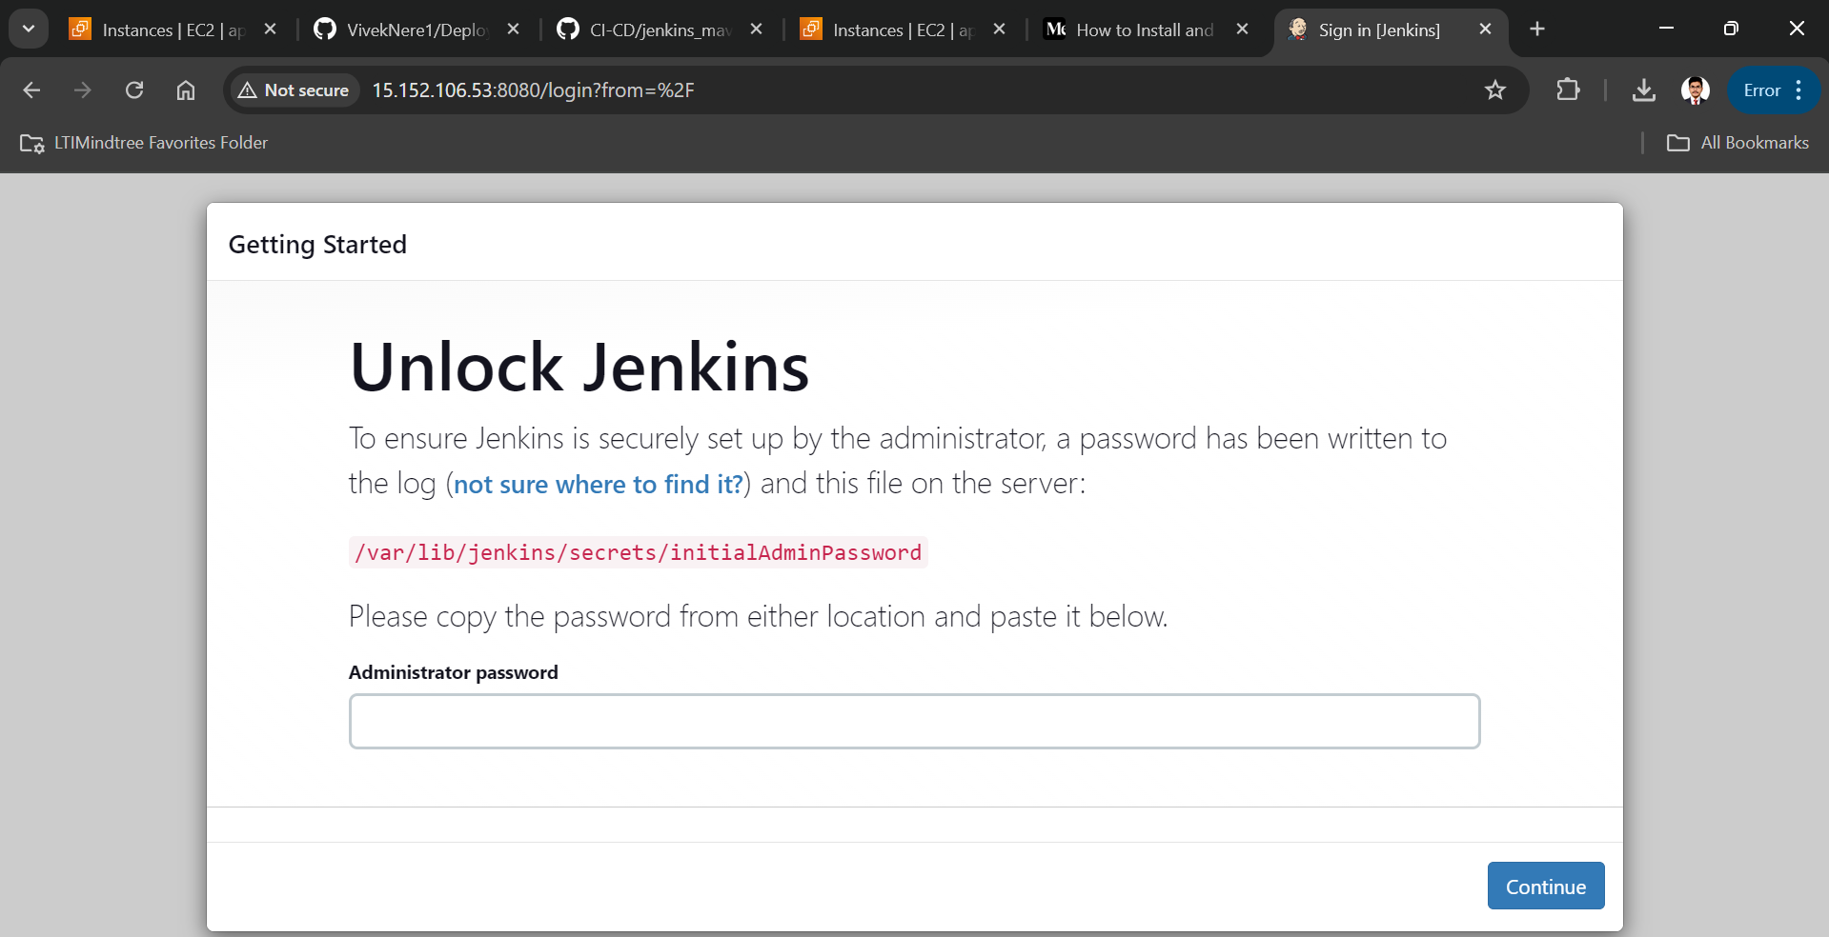

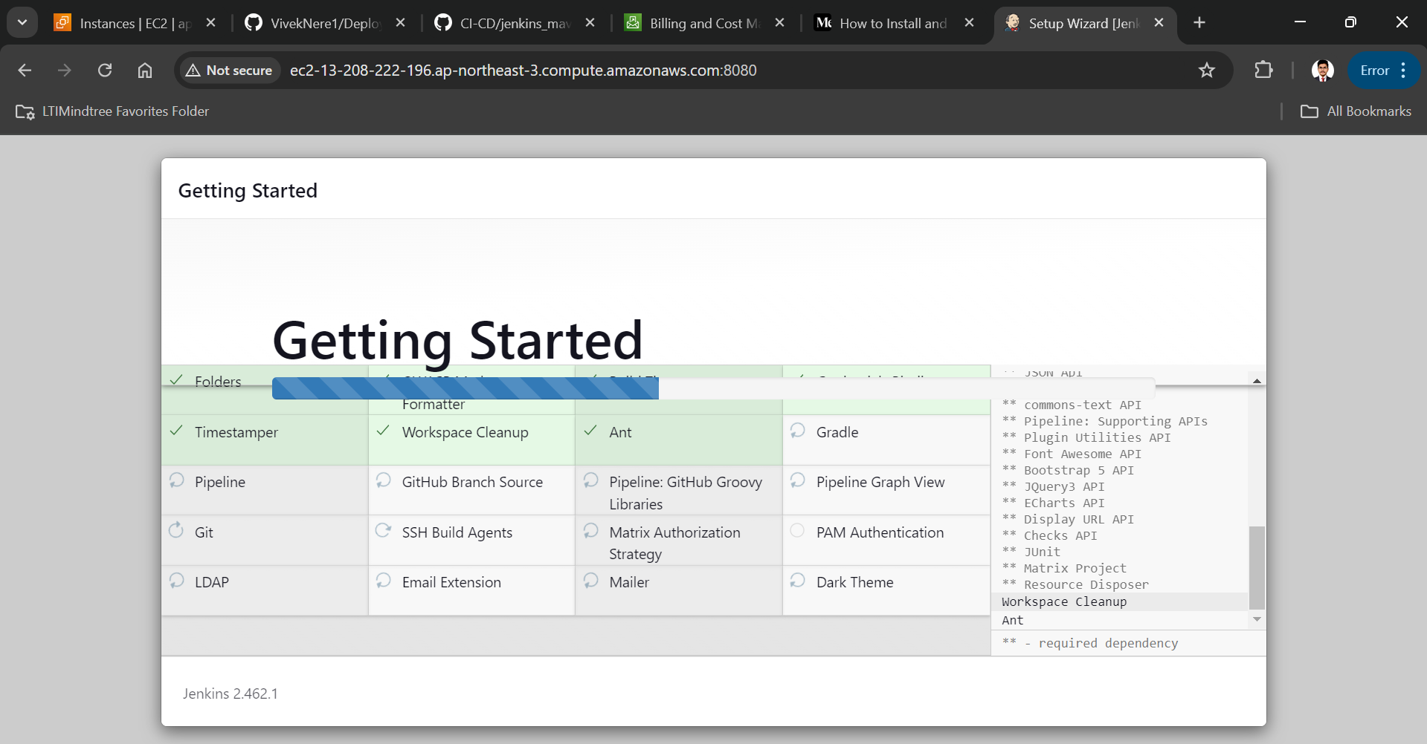

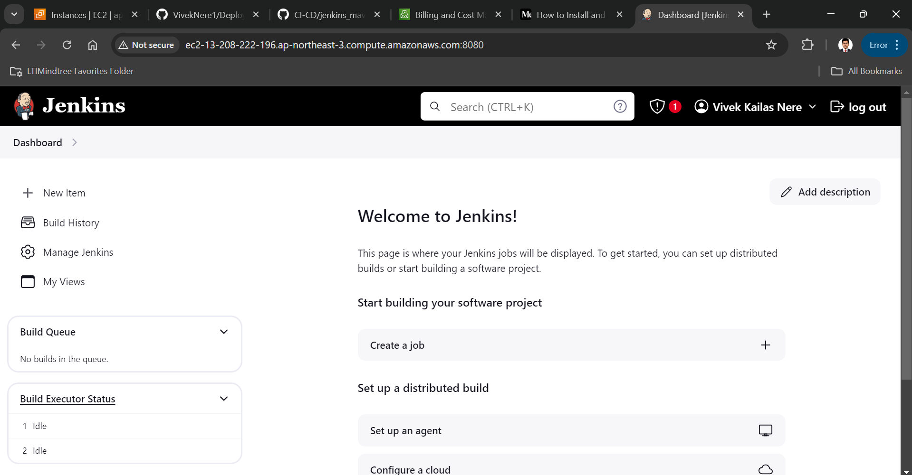

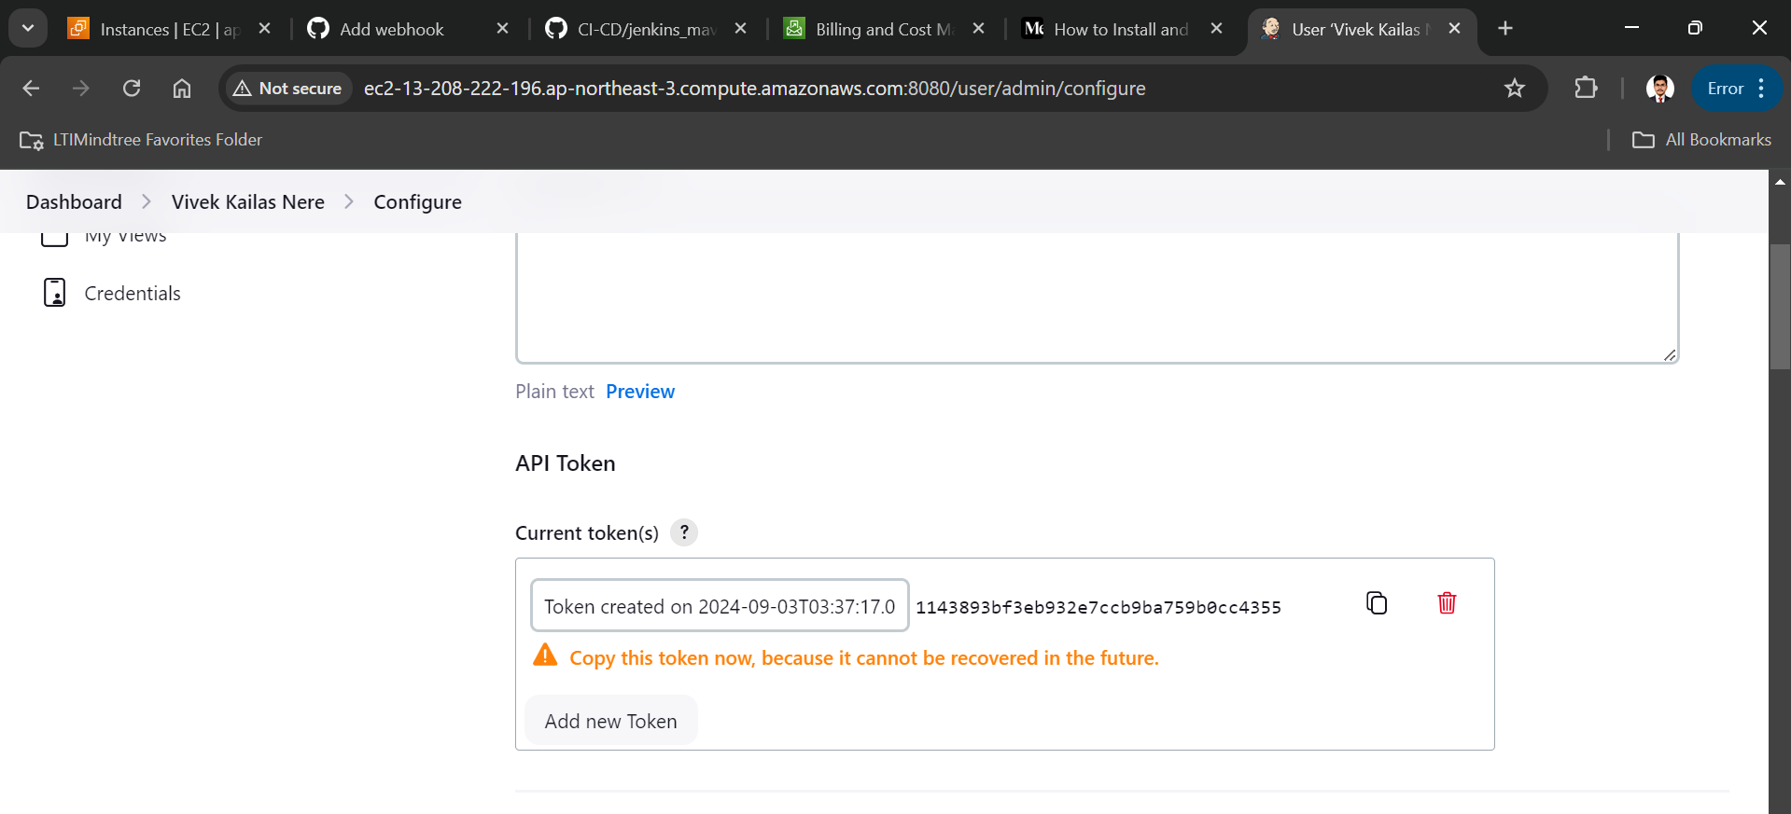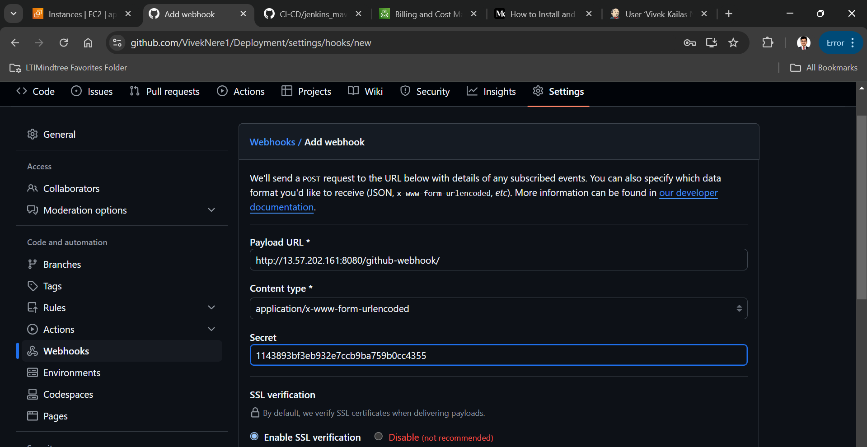

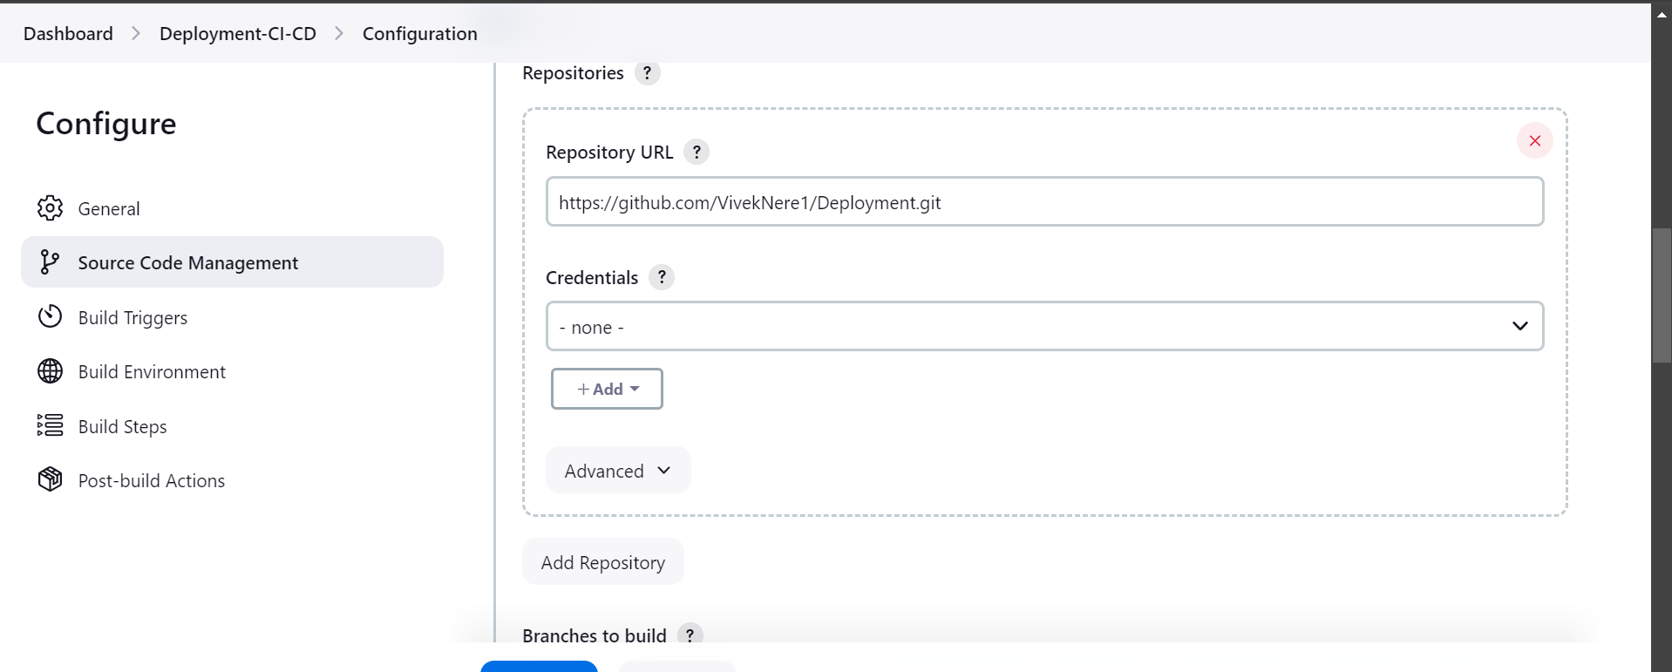

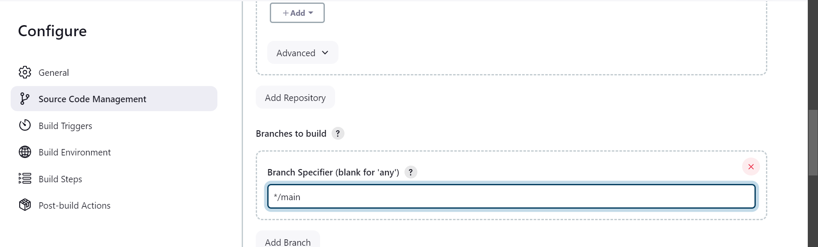

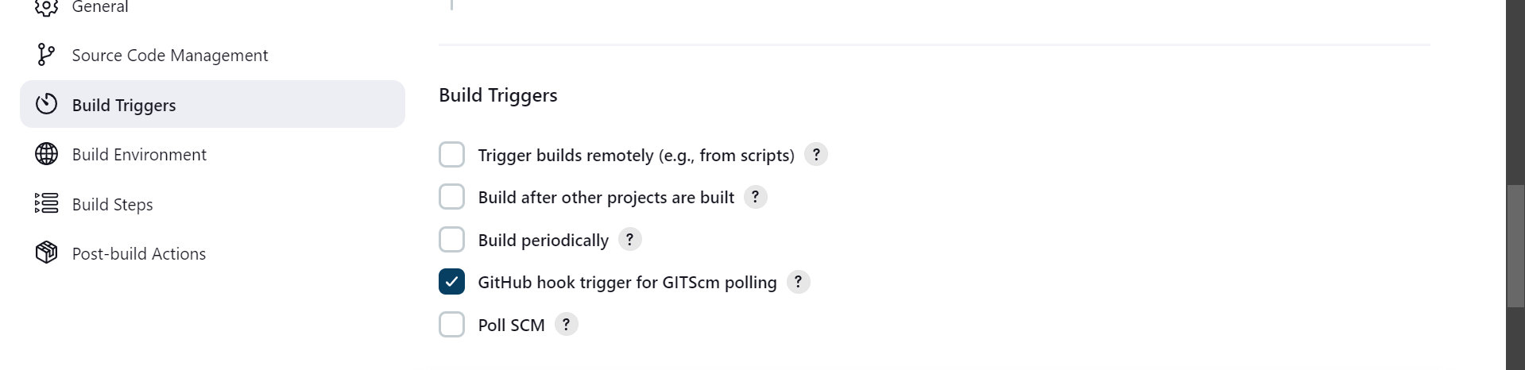

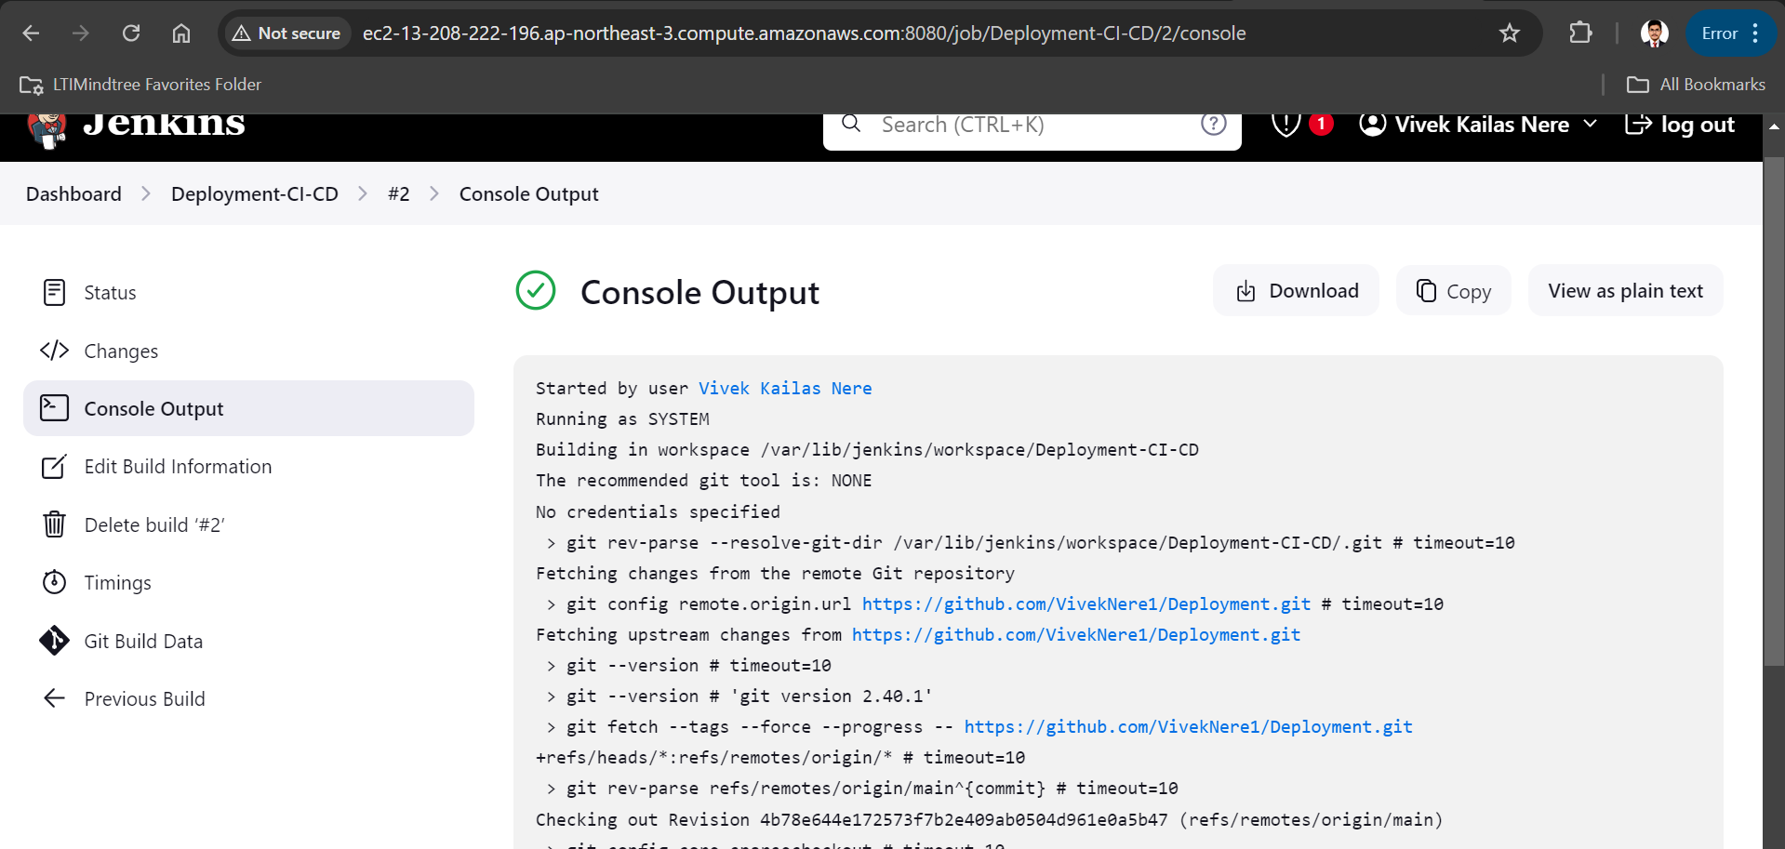

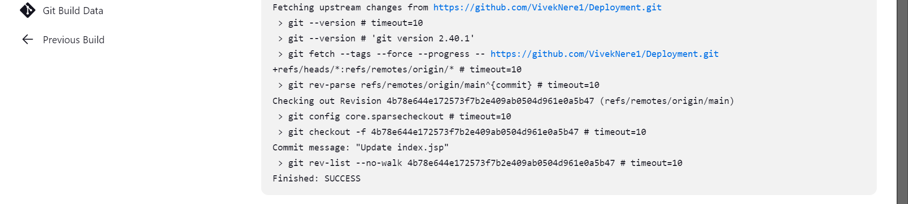

#Installation and Configuration of maven:

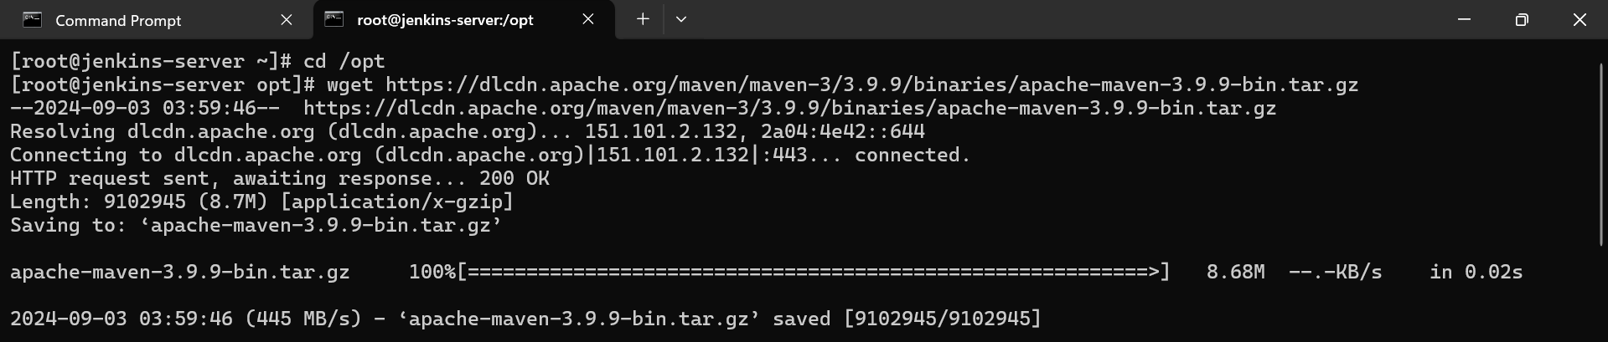

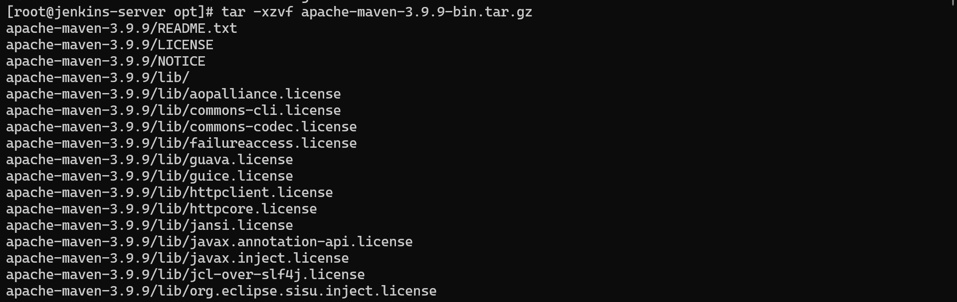

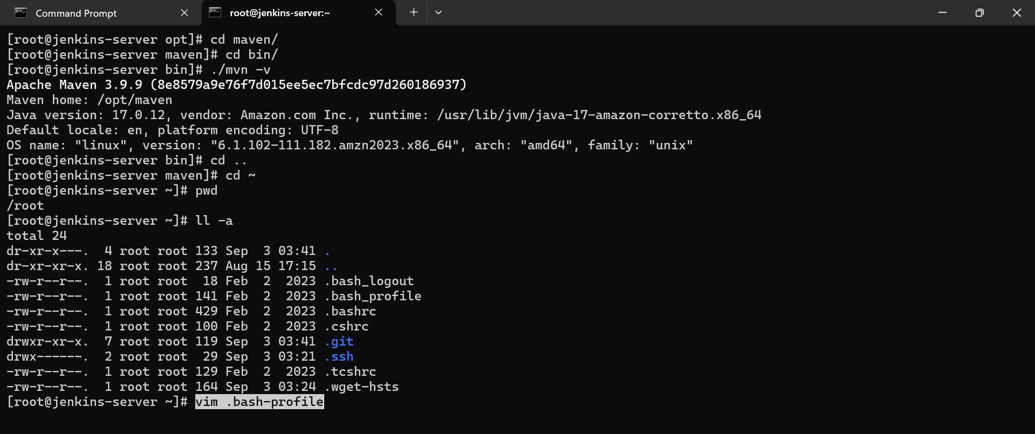

#Install maven plugins and configure Jenkins for maven

in Jenkins -> manage Jenkins -> plugins -> available plugins -> install maven integration

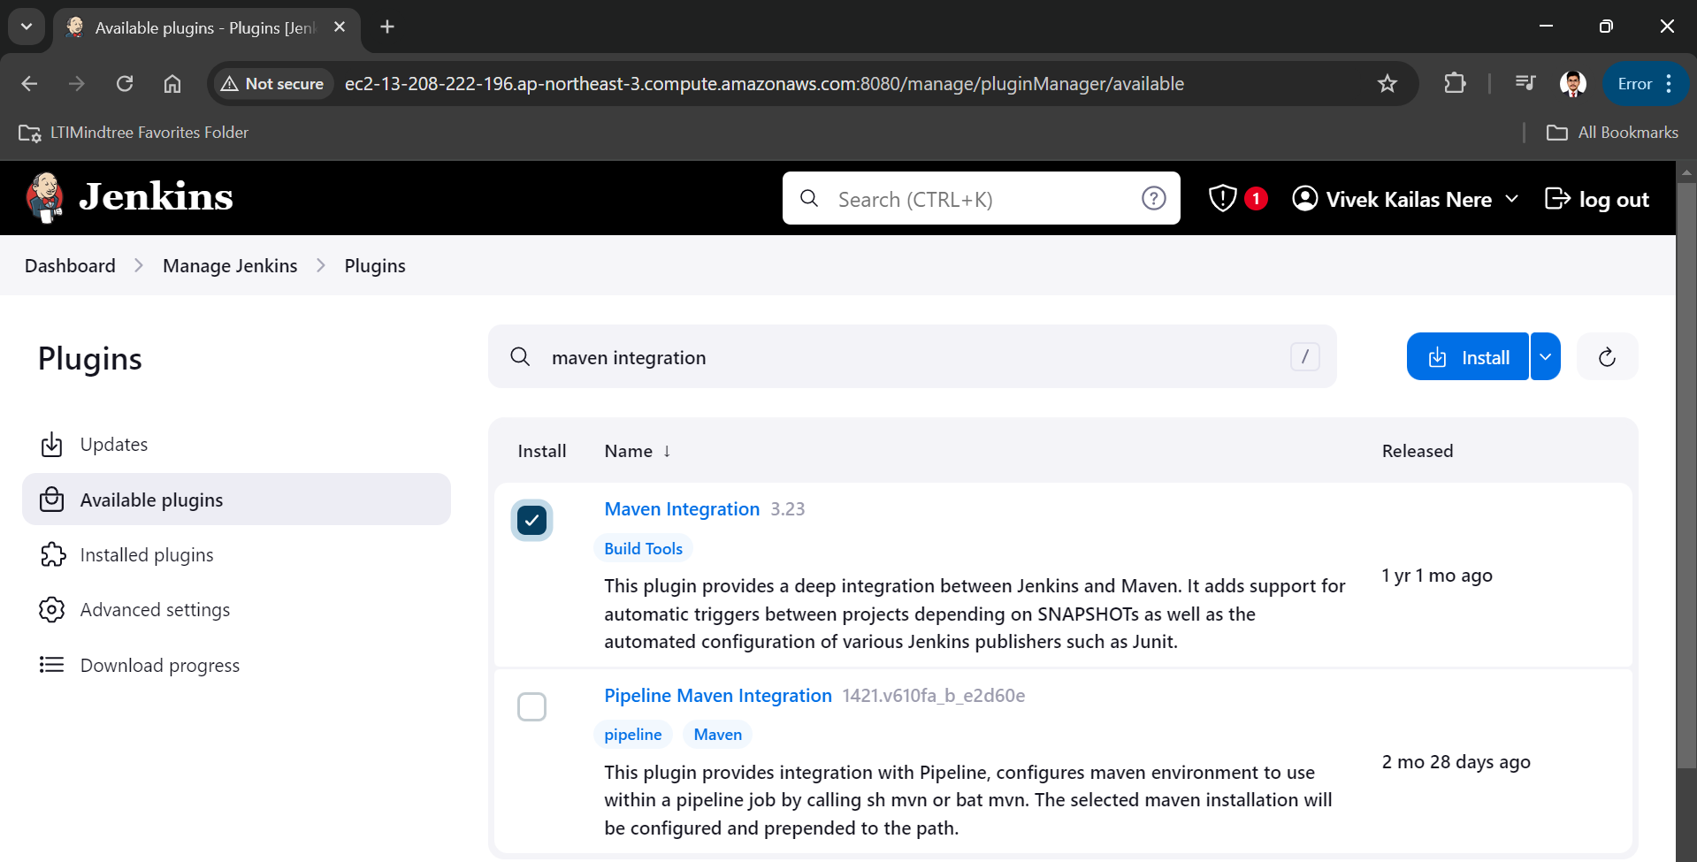

To find out the home directory of maven and java

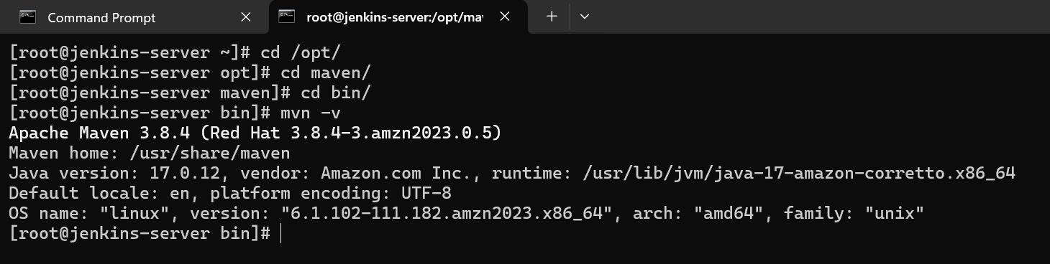

* now we need to configure this plugins for that go to manage Jenkins

tools-> add JDK -> name=java11 JAVA_HOME=/usr/lib/jvm/jre-17-openjdk

then add maven ==> name=maven , MAVEN_HOME= /usr/share/maven

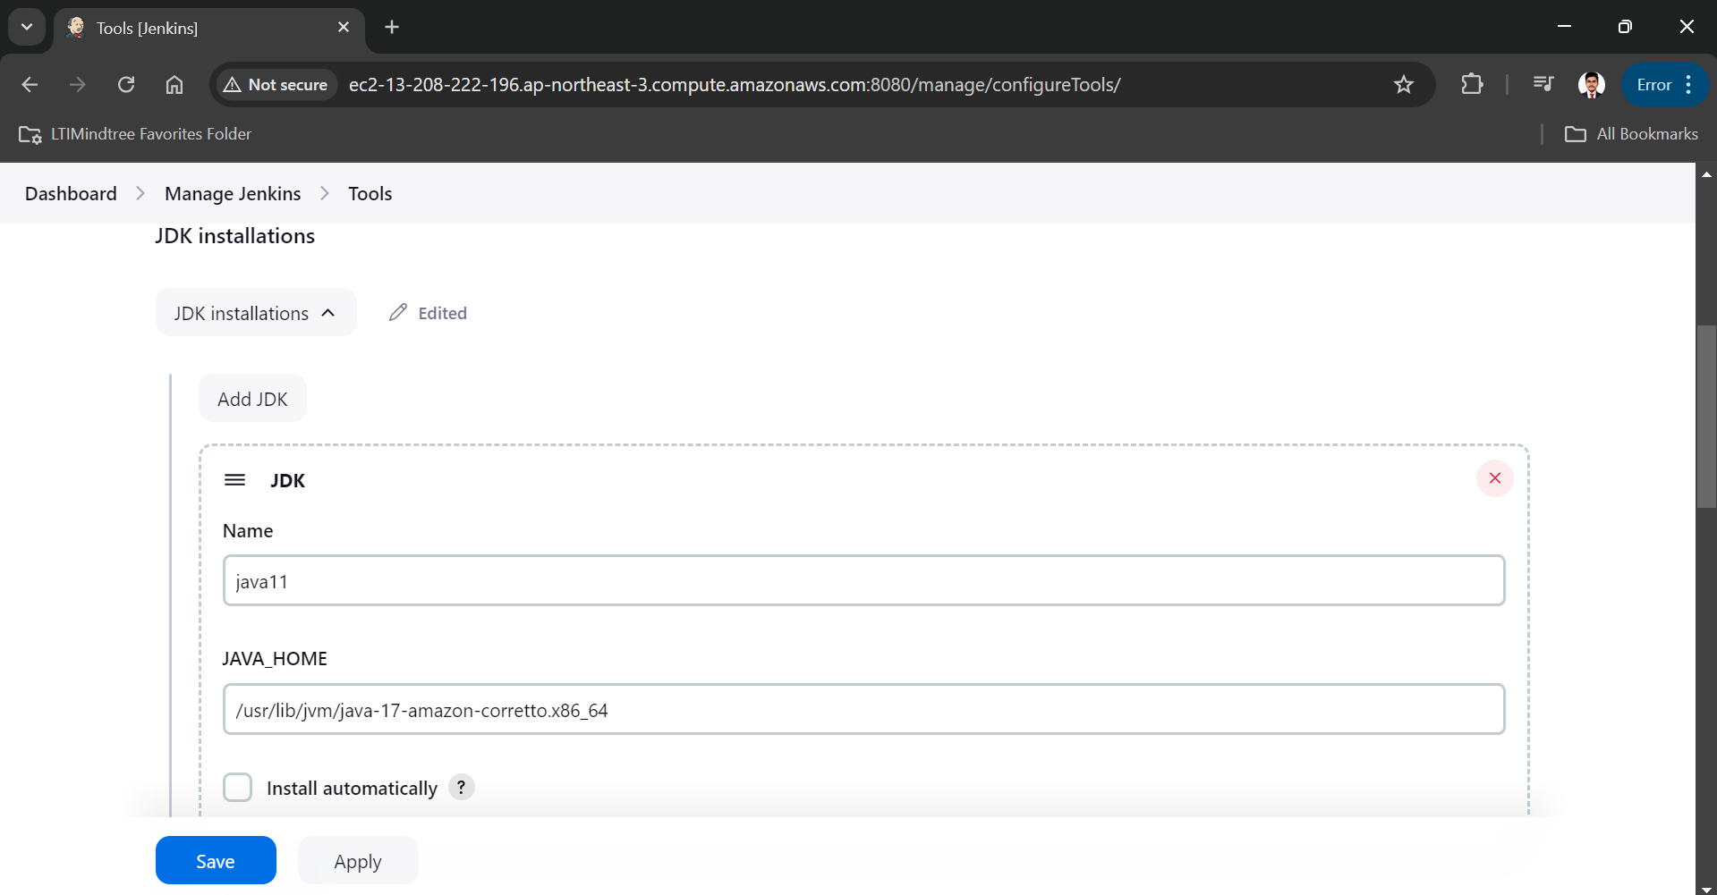

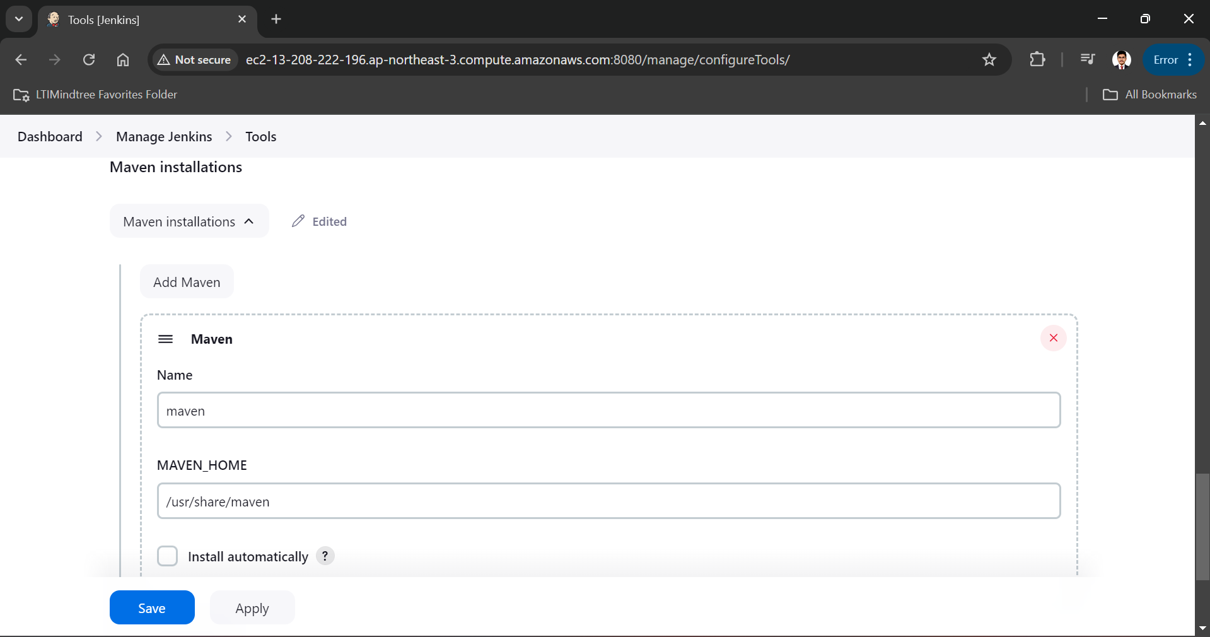

* now manage Jenkins -> plugins -> Intsalled plugins -> Disable the GITHUB branch source plugins & enable GitHub plugin and restart.

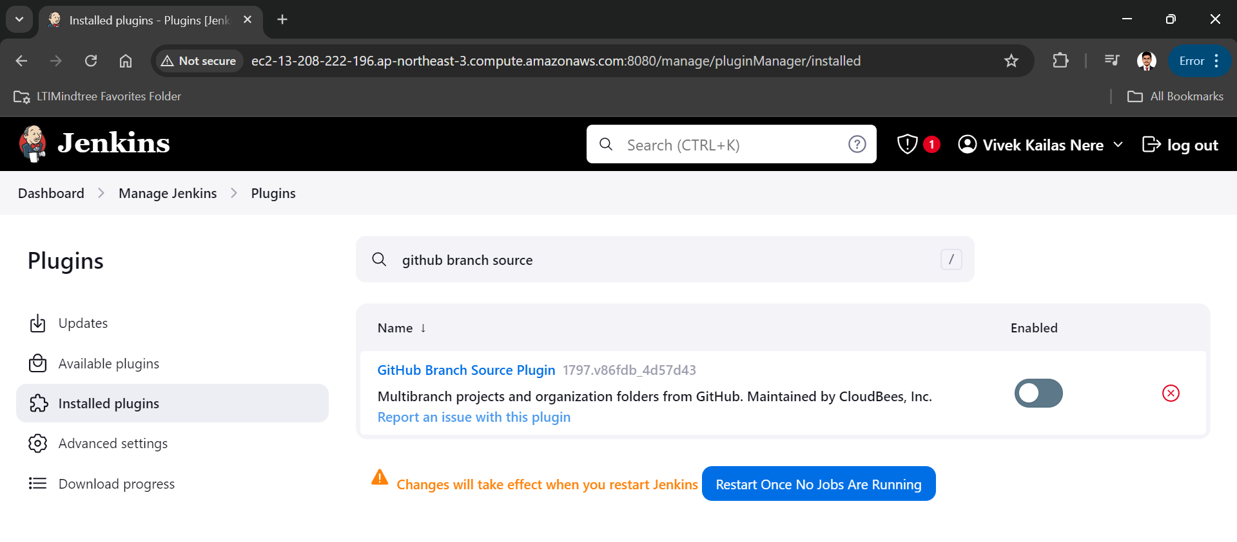

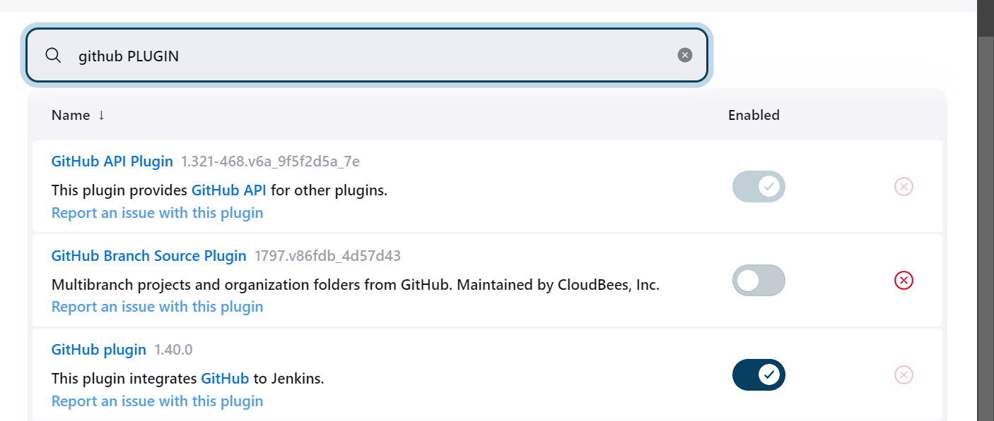

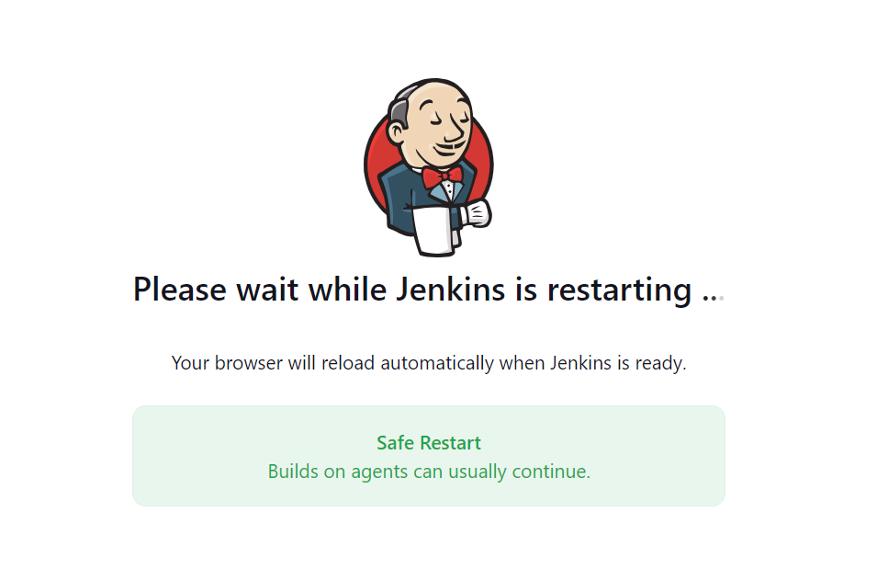

#Installation and configuration of Tomcat:

Open the tomcat-server instance into local machine by using ssh and set a hostname as tomcat-server

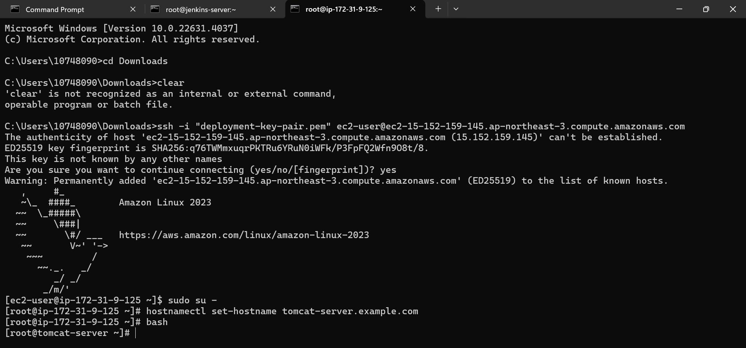

Installed java in tomcat-server

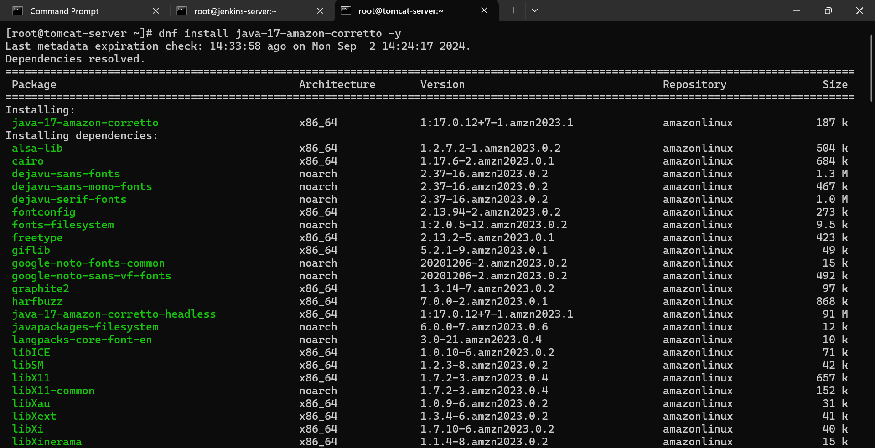

Download tar file of tomcat from tomcat official website in /opt folder

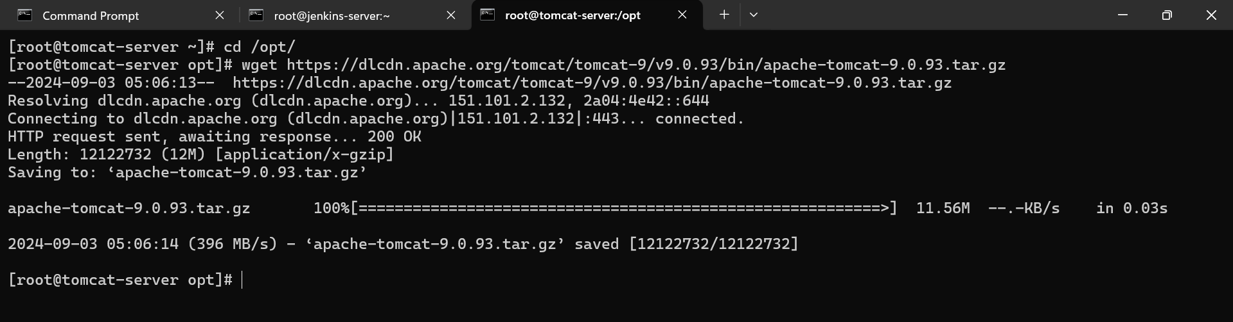

Extract tar file:

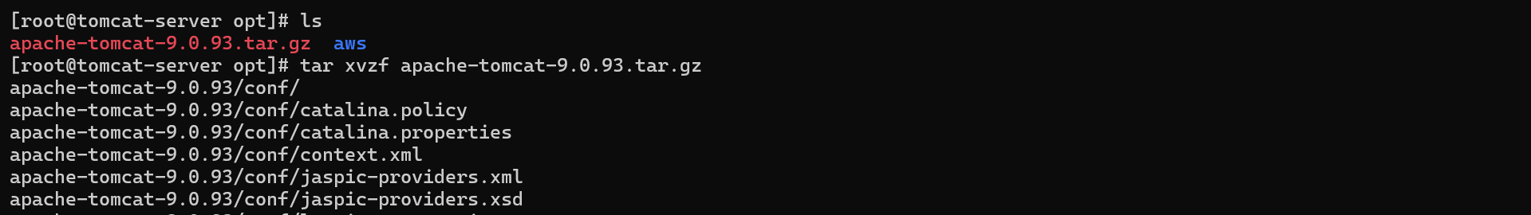

Move in tomcat folder

Now we have to start the tomcat server

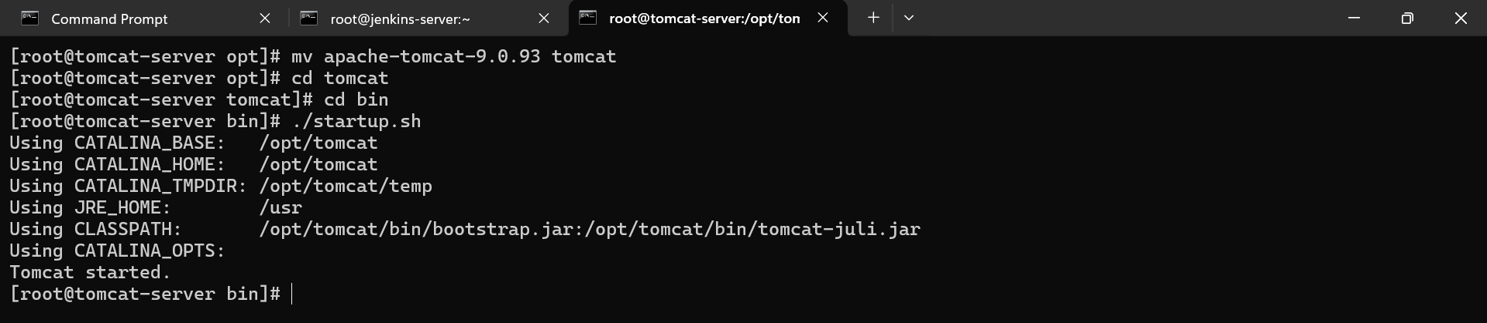

in google open http://(ip of tomcat server instance):8080

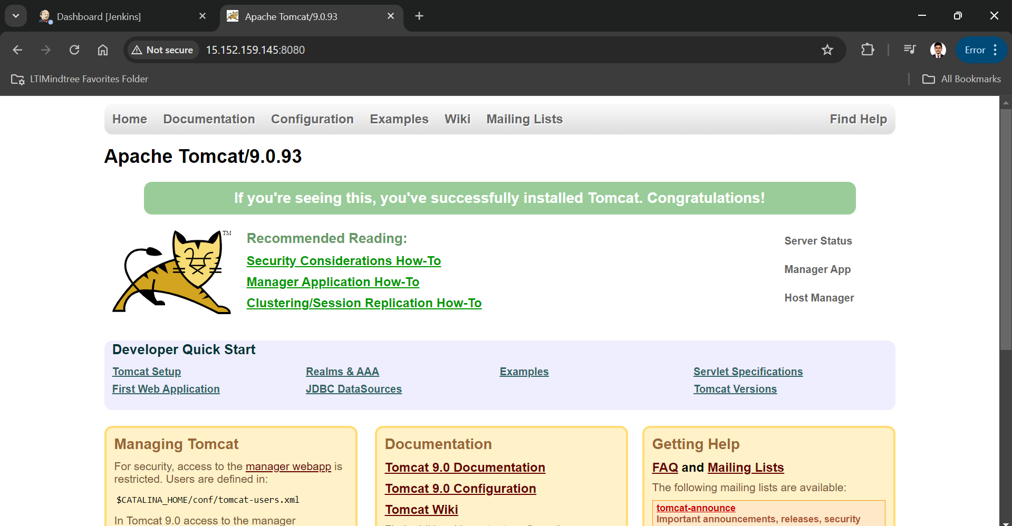

now we have make some changes in context.xml file for that we need to find that file in tomcat

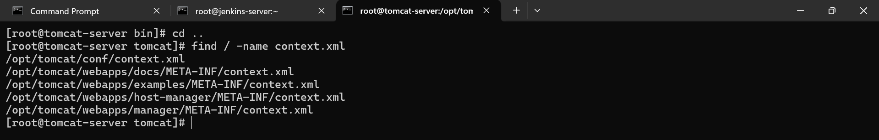

#comment value tag sections in below all files

[root@tomcat-server bin]# vim /opt/tomcat/webapps/examples/META-INF/context.xml

[root@tomcat-server bin]# vim /opt/tomcat/webapps/host-manager/META-INF/context.xml

[root@tomcat-server bin]# vin /opt/tomcat/webapps/manager/META-INF/context.xml

<!-- <Valve className="org.apache.catalina.valves.RemoteAddrValve"

allow="127\.\d+\.\d+\.\d+|::1|0:0:0:0:0:0:0:1" /> --!>

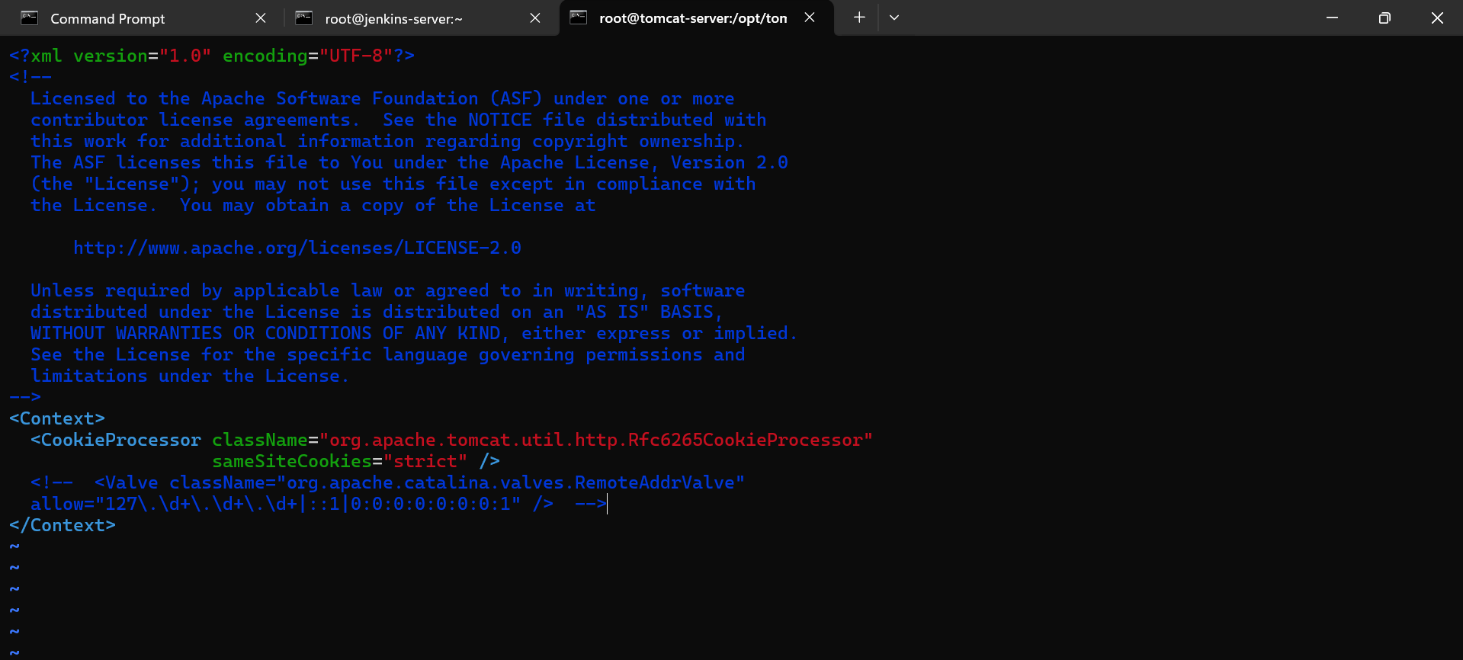

Now we need to change tomcat user configuration info:

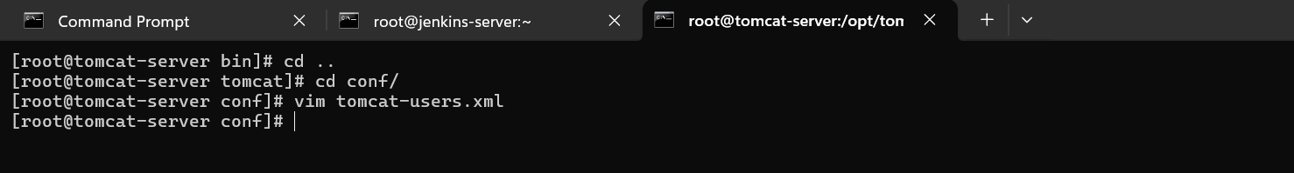

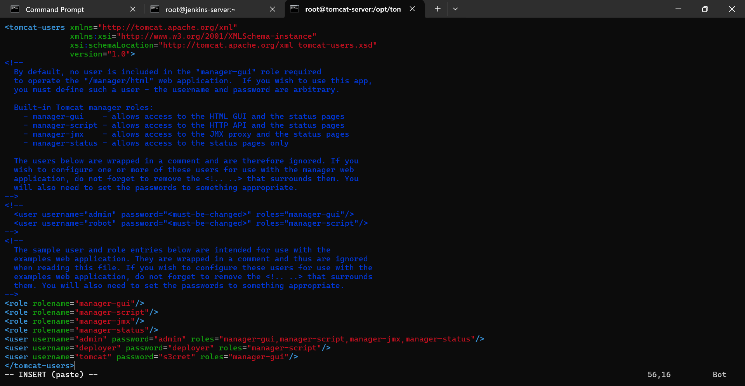

now we need to reboot the tomcat server

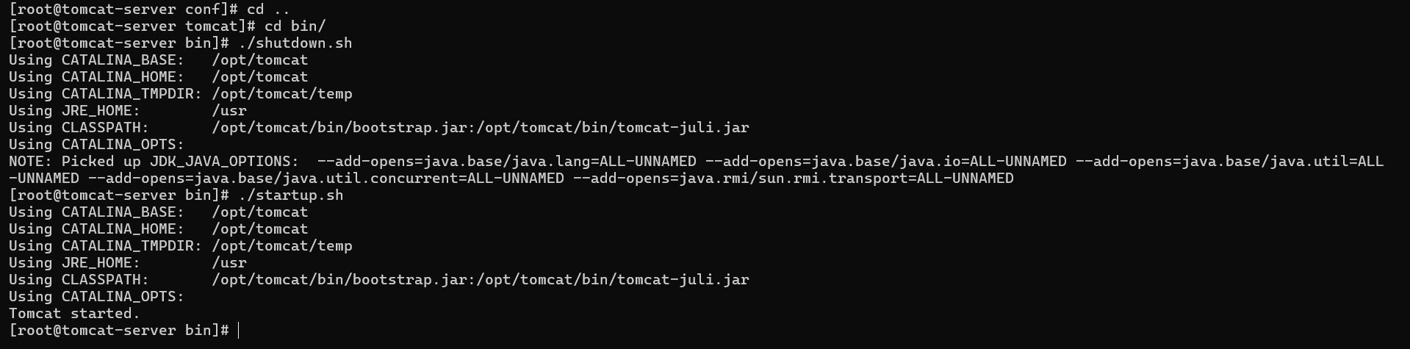

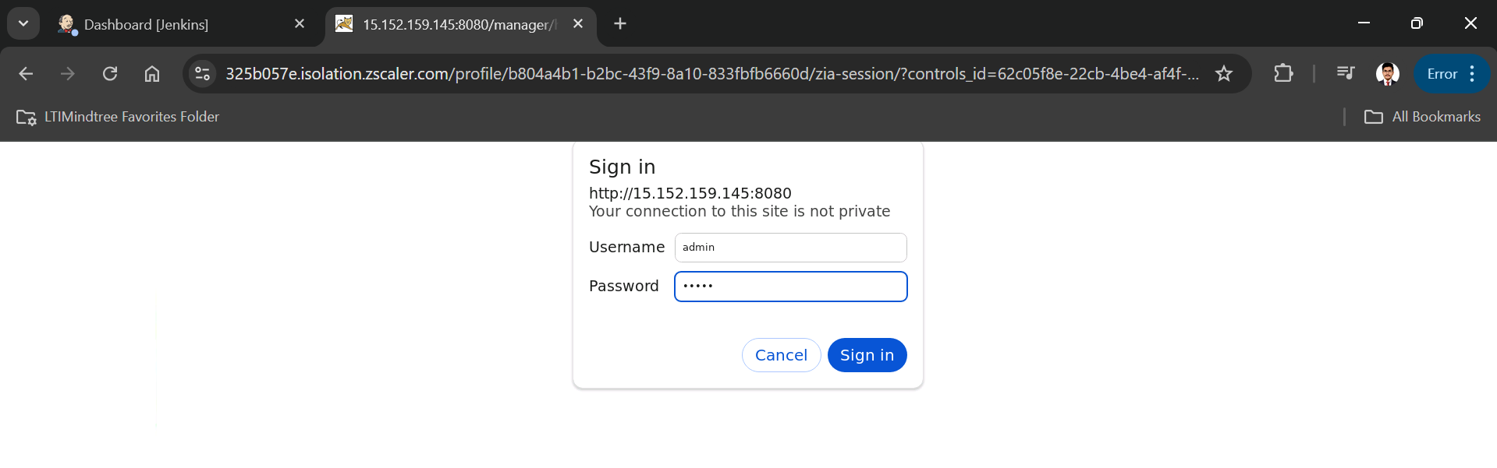

Integrating tomcat server with Jenkins:

there is no predefined tomcat plugin in Jenkins so we need to install "deploy to container plugin" then configure the tomcat server with credentials

manage genkins -> plugins -> available plugins -> deploy to container

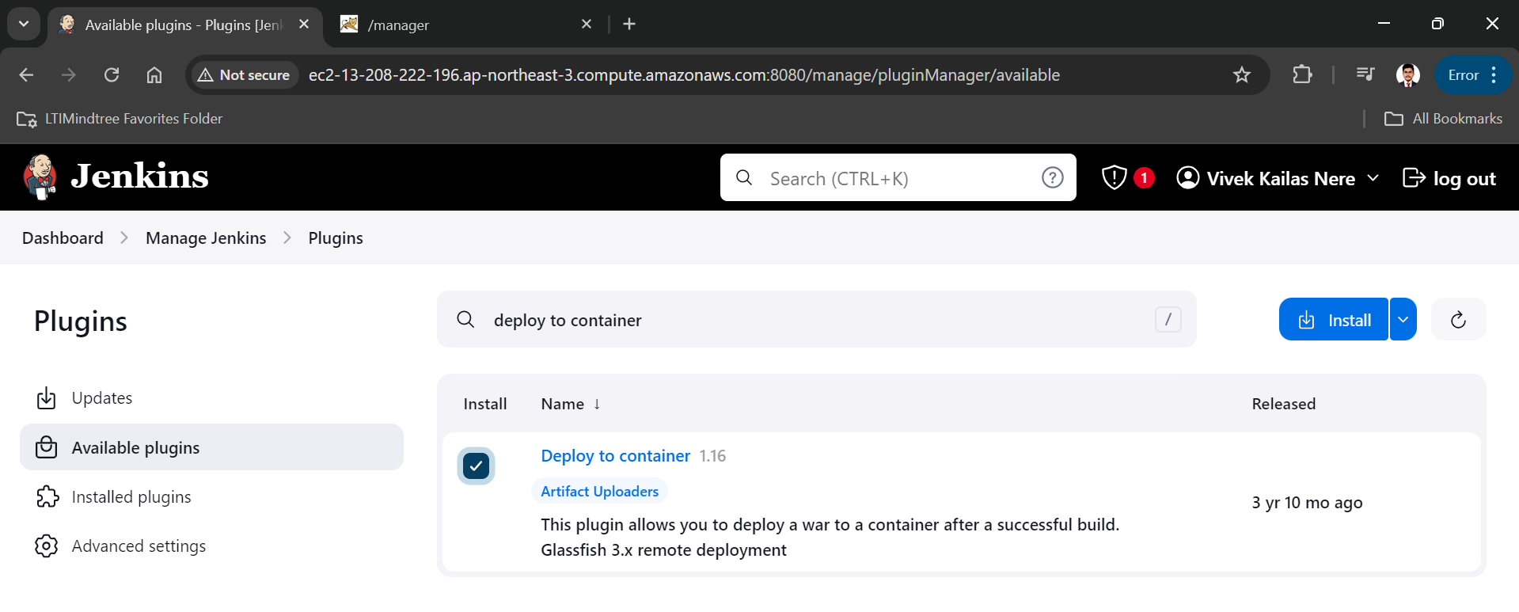

now we need to add credentials of tomcat to the Jenkins

manage Jenkins -> credentials -> system -> global credentials -> add credentials(<user username="deployer" password="deployer" roles="manager-script"/>) id and description=tomcat-credentials

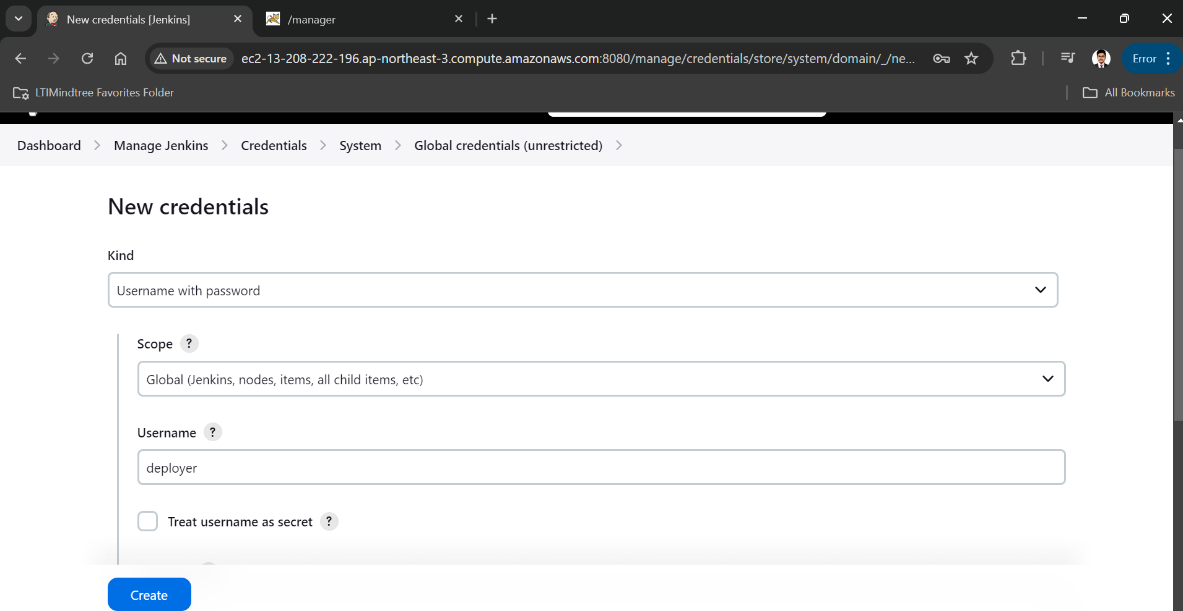

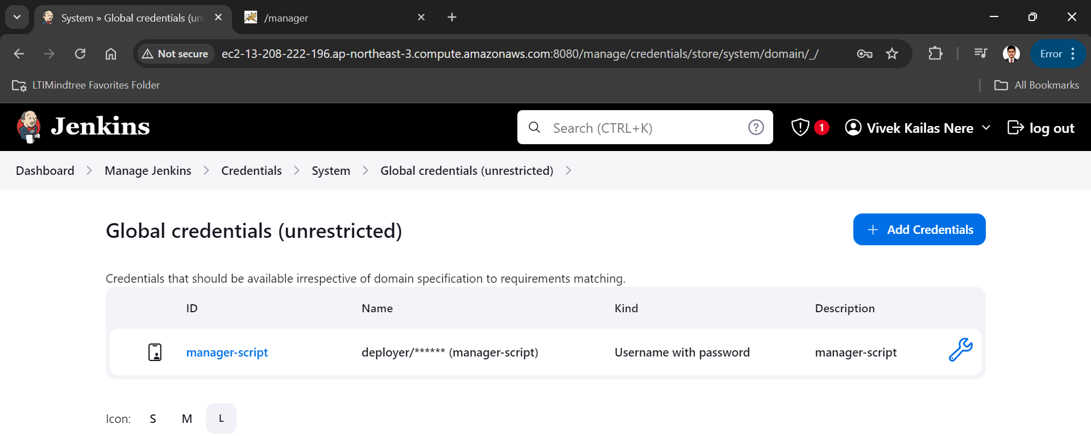

then go to dashboard and create new item name as BuildAndDeployToTomcat as a maven project

add git repository http url

make branch main

and at the last click on "Add post-build action" and select "Deploy war/ear to a container"

in war/ear file add "**/*.war"

add container Tomcat 8.x

add tomcat-server instance url

save and apply

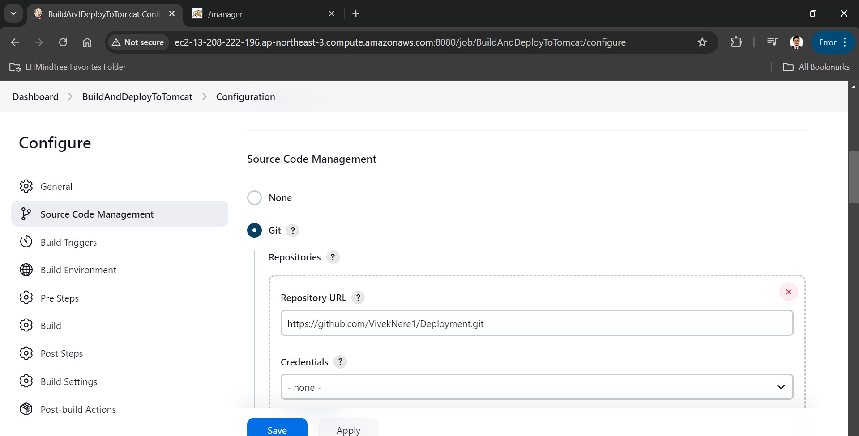

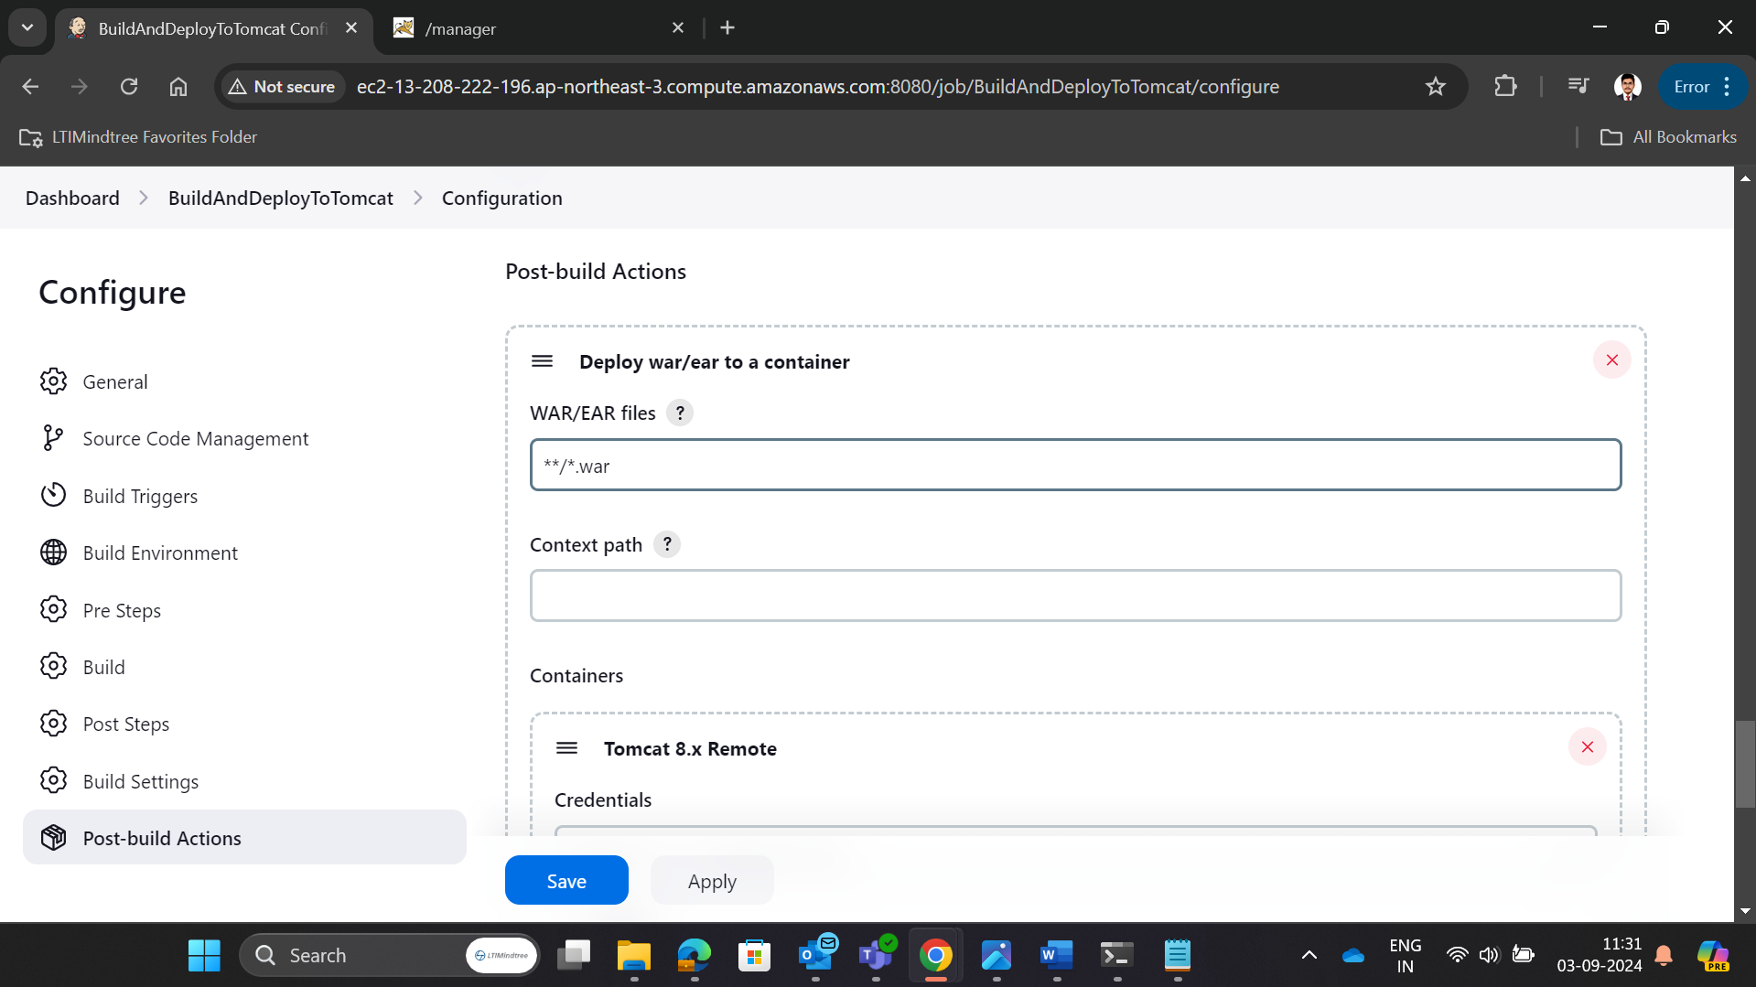

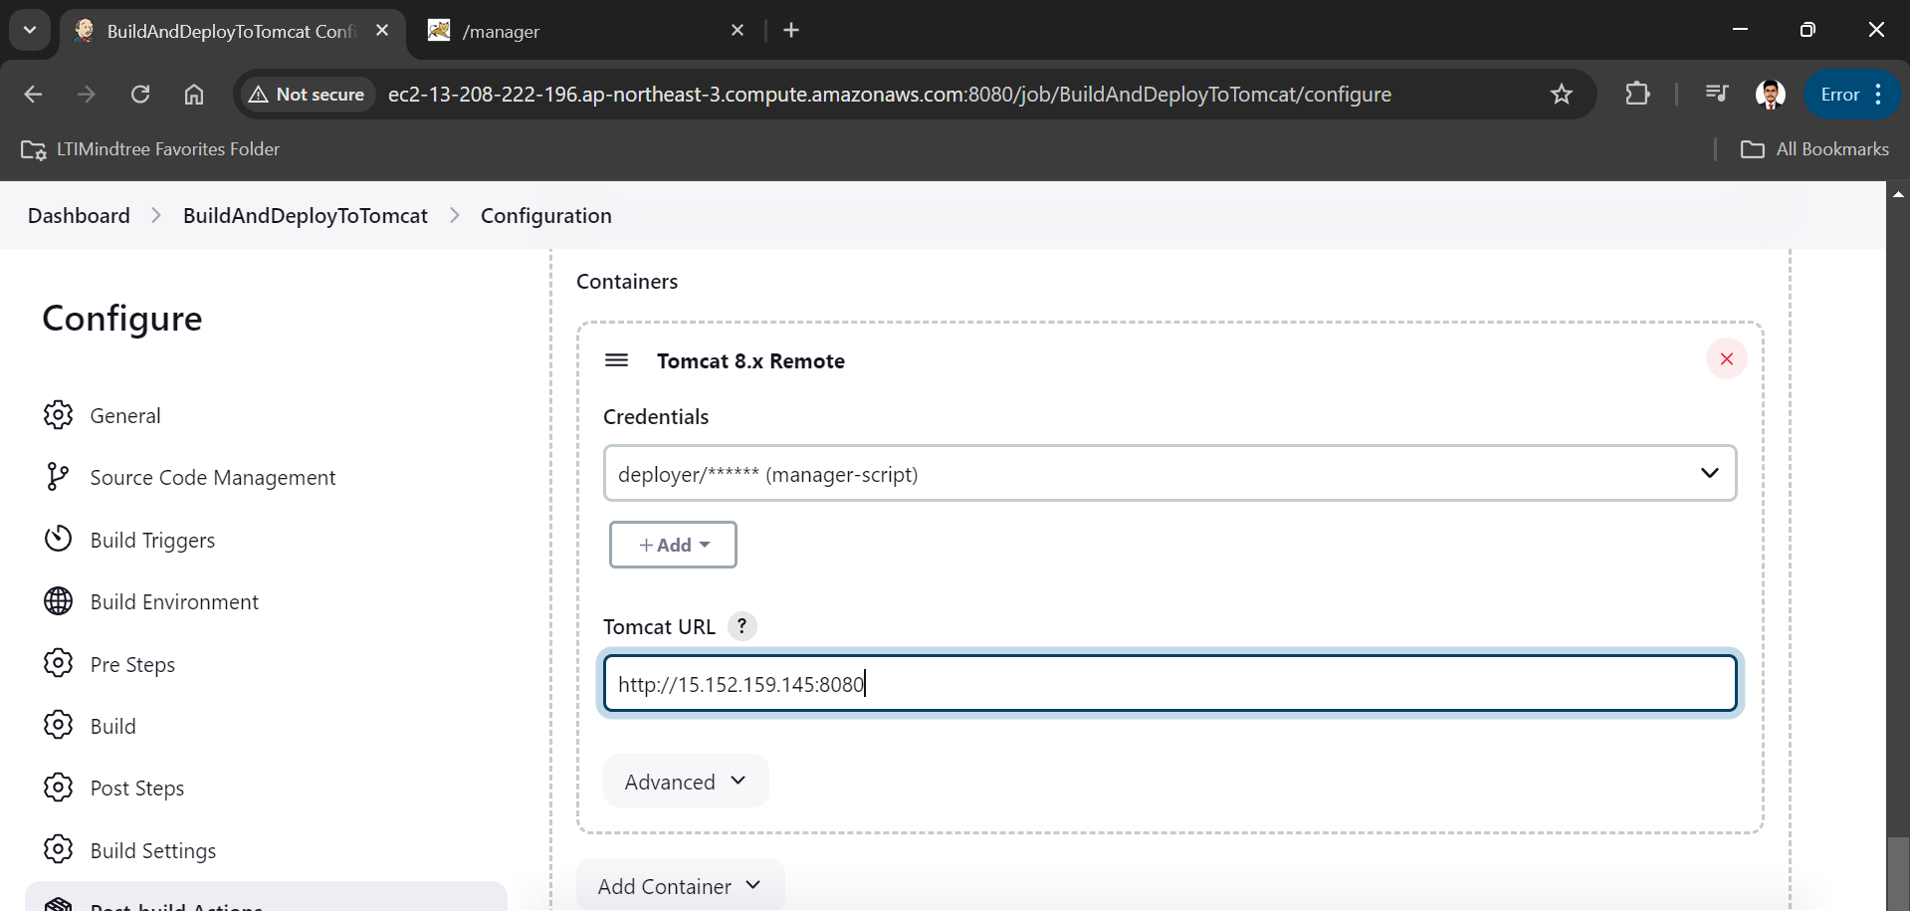

We have suceesfully deployed project on tomcat server

